A-PAG
Air Pollution Action Group
AI Knowledge &
Intelligence Platform
Scope & Technical Architecture
Version | 3.0 · Sign-off draft
Status | For review by A-PAG Leadership and the TCF AI & Technology Centre of Excellence
Priority order | 1. Conversational data access (text to SQL) 2. Knowledge base 3. Reporting 4. Intelligence feeds
Delivery window | 17 August 2026 → 29 January 2027, handover included
Classification | Confidential — internal circulation only

This document defines what A-PAG will build, why each choice was made, in what order, and what it will cost. Every decision in it is intended to survive a government audit, a donor review and a staff departure.

CONTENTS
PART A · THE CASE
1 Why We Are Building This 3
2 Who Will Use It 4
3 What the Platform Does — Four Pillars 5
PART B · THE ARCHITECTURE
4 Reference Architecture 7
5 Classification and the Sovereignty Boundary 8
6 Identity, Roles and Access Control 11
7 Conversational Data Access — Text to SQL 13
8 The Document Pipeline 16
9 Knowledge and Retrieval 18
10 Multi-Provider Model Routing 19
11 Orchestration and the Agent Fleet 22
12 Agent Specifications 24
13 Guardrails and Answer Integrity 34
14 Data Architecture 35
15 Observability, Audit and Cost Control 37
16 Deployment and Engineering Practices 38
PART C · DELIVERY
17 Delivery Plan and Dependencies 40
18 What This Costs 42
19 Risks 43
20 The Correction Loop and Standing Reports 44
21 Open Decisions and Sign-Off 45
APPENDICES
A Open-Source Component Register 48
B Glossary 49
C Classification Quick Reference 50

THE THREE COMMITMENTS THIS ARCHITECTURE KEEPS
1. A-PAG's knowledge stays inside A-PAG. Sensitive material is protected by software that fails closed, not by a vendor's promise in a contract.
2. Every answer carries its provenance — a source paragraph for a narrative answer, the exact query and as-of date for a number. An answer that cannot show its working is refused, not disclaimed.
3. A human decides anything that leaves the building.

PART A · THE CASE

1 Why We Are Building This
PROBLEM · ALTERNATIVES · WHAT SUCCESS LOOKS LIKE
A-PAG has no information shortage. It has a retrieval, trust and retention problem, and it shows up in two distinct places.
- Numbers. Getting a figure means opening a dashboard, finding the right tab, applying three filters, and discovering the view you need was never built. Then you raise a ticket and wait. Most questions staff have about A-PAG's own performance are questions no dashboard was pre-built to answer.
- Documents. Reports, policies, field notes and institutional memory sit across Drive, email, WhatsApp, spreadsheets and people's heads. Locating the current CAQM report means searching four places and still not knowing whether the copy found is final or superseded. When someone leaves, part of the organisation's understanding leaves with them.
This platform addresses both, in that order. Conversational access to data is built first because the problem is sharper, the scope is smaller, and — critically — the answer is immediately verifiable against a query the user can see.
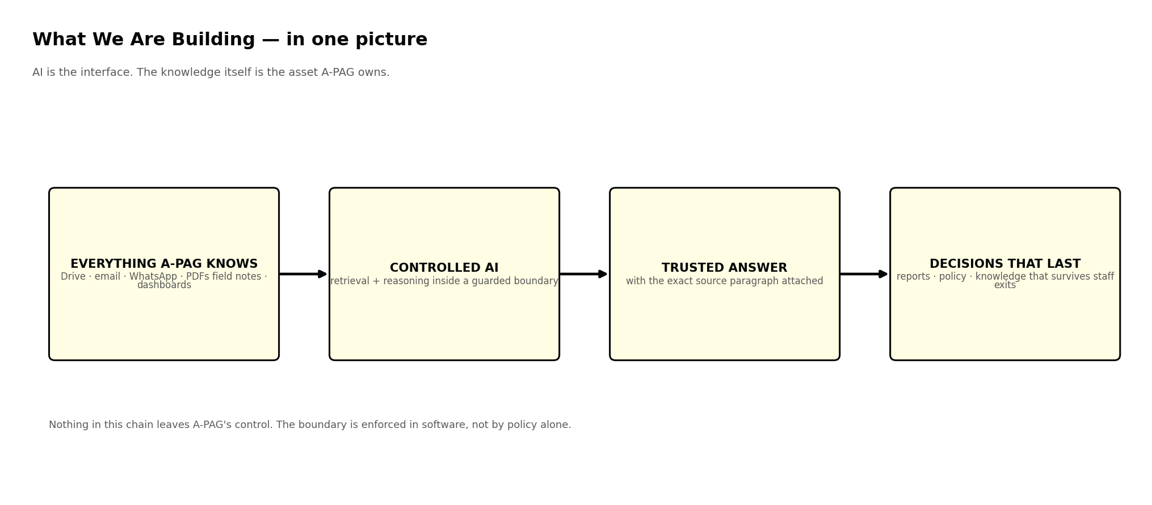
Figure 1 AI is the interface. The knowledge is the asset A-PAG owns permanently.

1.1 Why not simply buy an enterprise AI licence?
An enterprise licence for a hosted assistant is fast to buy and genuinely useful. It fails five requirements that are not negotiable for an organisation working with government data.

Requirement | Why a closed, hosted tool does not satisfy it
Data sovereignty | Draft policies, government correspondence and donor financials must stay inside A-PAG's boundary. A hosted tool moves them outside it, and a contract is not an enforcement mechanism.
Access to A-PAG's own database | No hosted assistant can query A-PAG's operational data under A-PAG's own row-level permissions. That is the entire first pillar, and it is not purchasable.
Organisational memory | A general model knows the public web. It does not know A-PAG's reports, unpublished field work, impact metrics, or the reasoning behind past decisions. That reasoning is the actual asset.
Full audit trail | Stakeholders need to see who asked, which document version or query produced the answer, and who approved it. Hosted tools rarely expose this depth.
Compounding returns | Corrections made inside a hosted tool improve the vendor's product. Made inside A-PAG's platform, they improve A-PAG's institutional knowledge permanently.

1.2 The decision
A-PAG builds and owns the platform. Every component that stores, indexes, searches, orchestrates or audits is open-source software on infrastructure A-PAG controls. The single exception is language-model inference for non-restricted content, served by an external API under an enterprise data-processing agreement and reachable only through the gateway in Chapter 5, which redacts what it sends and refuses to send restricted material at all.
WHAT THIS PROJECT IS NOT
This is not a cost-reduction project, and should not be presented to the board as one.
A-PAG pays roughly ₹23,000 per month for external AI covering 23 of 50 staff — about ₹1,000 per person. Owning the platform costs more in absolute rupees and roughly the same per person once all 50 are covered. What changes is that A-PAG owns the knowledge, controls the boundary, can prove to an auditor what happened, and keeps what departing staff know.
Anyone who sells this internally as a saving will be embarrassed in Month 6.

1.3 What success looks like
Every measure is baselined during Phase 0, in the weeks from 17 August 2026. A measure not baselined before the build starts cannot be claimed at handover.

Measure | Target | Measured by | How
Time from question to a trusted number | − 90% | Nov 2026 | Timed sample of twenty routine data questions, same staff, before and after
Long-tail dashboard views retired | ≥ 70% | Dec 2026 | Count of pre-built views still in weekly use after Phase 2
Time to locate a known document | − 80% | Jan 2027 | Timed retrieval task over a fixed set of twenty documents
Answers delivered with valid provenance | 100% | continuous | System-enforced; a breach is a defect, not a metric
Handover accepted | pass | 29 Jan 2027 | The receiving team runs the platform in production for two weeks with the build team on standby only

Two measures from earlier drafts — time to compile a briefing note, and knowledge retained after a staff exit — depend on the Report and Knowledge Transfer Agents, which sit after handover. They are baselined now and claimed later, not claimed now.

2 Who Will Use It
EIGHT TEAMS · EIGHT SCOPED WORKSPACES
Each team gets a workspace scoped to what it does. Scope is enforced technically, not by convention: a document or a database row a user is not cleared to see is never retrieved, never ranked, and never sent to a model on that user's behalf. The mechanism is Chapter 6.

Team | Workspace built around | Notable restriction
CEO Office | Executive briefings, cross-departmental status, strategic KPIs, board summaries, urgent alerts | Sees all tiers including Restricted
Strategic, Planning & Policy | Policy research, CAQM / CPCB / MoEFCC tracking, external intelligence feed | No access to donor financials
Fundraising | Donor reports, proposals, funding pipeline, impact evidence | Donor financials Restricted to this team and CEO Office
Process Excellence | SOPs, process documentation, knowledge-base quality, coordination records | Read-wide, write-narrow
CPCB / Regulatory Liaison | Circulars, compliance records, government correspondence, policy mapping | Correspondence defaults to Confidential
HR | Employee policies, onboarding, knowledge-transfer records, org structure | Individual employee records excluded from AI answering entirely
Accounts | Budget variance, expenditure, donor financial reporting, audit documents | Scoped to Accounts and CEO Office only
IT | System health, pipeline status, access management, observability | Administrative access requires VPN and MFA

3 What the Platform Does — Four Pillars
IN PRIORITY ORDER · PILLAR 1 SHIPS FIRST

Pillar 1 · Conversational Data Access — the first priority
Every dashboard assumes the user already knows what they are looking for: open the screen, find the report, apply the filters, and hope the view you need exists. If it does not, you wait for a developer. This is the bottleneck for every non-technical person who needs a number, and it is the problem the platform solves first.
A staff member types the question the way they would ask a colleague and gets the answer in seconds — with the exact query that produced it, the number of rows it covered, and the date the data was last updated. The number can be challenged by anyone, without going through the IT team.

The old way | With Pillar 1
Open dashboard, find the tab, apply three filters | Type the question in plain language
Discover the view you need was never built | Any combination of fields, within your permissions
Raise a ticket and wait for a developer | Answer in seconds, no technical person involved
A number with no trail of how it was produced | The query, row count and as-of date shown every time
Everyone quotes a slightly different figure | One certified definition per metric, used by everyone

ON RETIRING DASHBOARDS — THE HONEST RECOMMENDATION
Retire the long tail; keep the canonical few. A question asked every single morning should not require typing it. Roughly five standing boards — programme status, budget position, air-quality headline, deliverable tracker, fundraising pipeline — should survive. Everything beyond that, which is where the maintenance burden and the stale views actually live, is replaced by conversational access. Retiring every dashboard on day one converts a solved daily routine into a typing exercise and costs the platform its early goodwill.

Pillar 2 · Knowledge Base and AI Chat
Everything A-PAG knows — documents, emails, reports, WhatsApp exports — ingested into one versioned, searchable archive. Ask a question in plain language, get an answer with the exact source paragraph attached.

The old way | With Pillar 2
Search Drive, email and WhatsApp separately | Ask once; one place searches everything you may see
Unclear whether the document found is current | A new version flags the old one automatically on upload
Ask three colleagues to find the right person | The system answers, with the source paragraph attached
When someone leaves, their knowledge leaves | Project history and decisions captured before access is revoked

Pillar 3 · Research and Report Generation
Producing a briefing note is a half-day task, and almost none of that time is spent thinking — it is spent searching, copying, formatting citations and assembling. This pillar replaces the assembly, not the judgement. The Research Agent returns cited findings; the Report Agent structures them into a first draft; the analyst reviews and decides. Nothing leaves without a named human approving it.

Pillar 4 · Intelligence Feed — external and internal
Two problems with one root cause: information exists but does not reach the people who need it. Outside the building, regulations and research are published daily across dozens of sources nobody has time to monitor. Inside it, one team completes a field visit and no other team knows.

Stream | What is captured | Refresh
Government portals | Notifications, orders and circulars from CAQM, CPCB, MoEFCC, PIB, state boards | Hourly
International bodies | Reports and advisories from WHO, UNEP, World Bank, US EPA, Copernicus | Daily
Research and academia | Peer-reviewed work via OpenAlex, Semantic Scholar, Crossref | Daily
News and live data | Media coverage via GDELT; air-quality readings from OpenAQ, AQICN, NASA | Hourly / 30 min
Internal updates | Field visits, deliverables, meeting outcomes, funding decisions, alerts | On post

The internal feed is not a group chat. Updates are permanent and searchable, classification applies so a grant's existence can be visible while its amount is not, and every update is a document the system can cite in a report. A WhatsApp message is none of those things.

PART B · THE ARCHITECTURE

4 Reference Architecture
EIGHT LAYERS · ONE RESPONSIBILITY EACH
Eight layers. Each has exactly one job and hands off to the next, because a layer with two jobs cannot be replaced without replacing both.
Every technical chapter that follows repeats this diagram with one layer highlighted in yellow and the rest greyed out, then gives a detailed diagram of that layer alone. Greyed components have not changed; they are simply not the subject of that chapter.
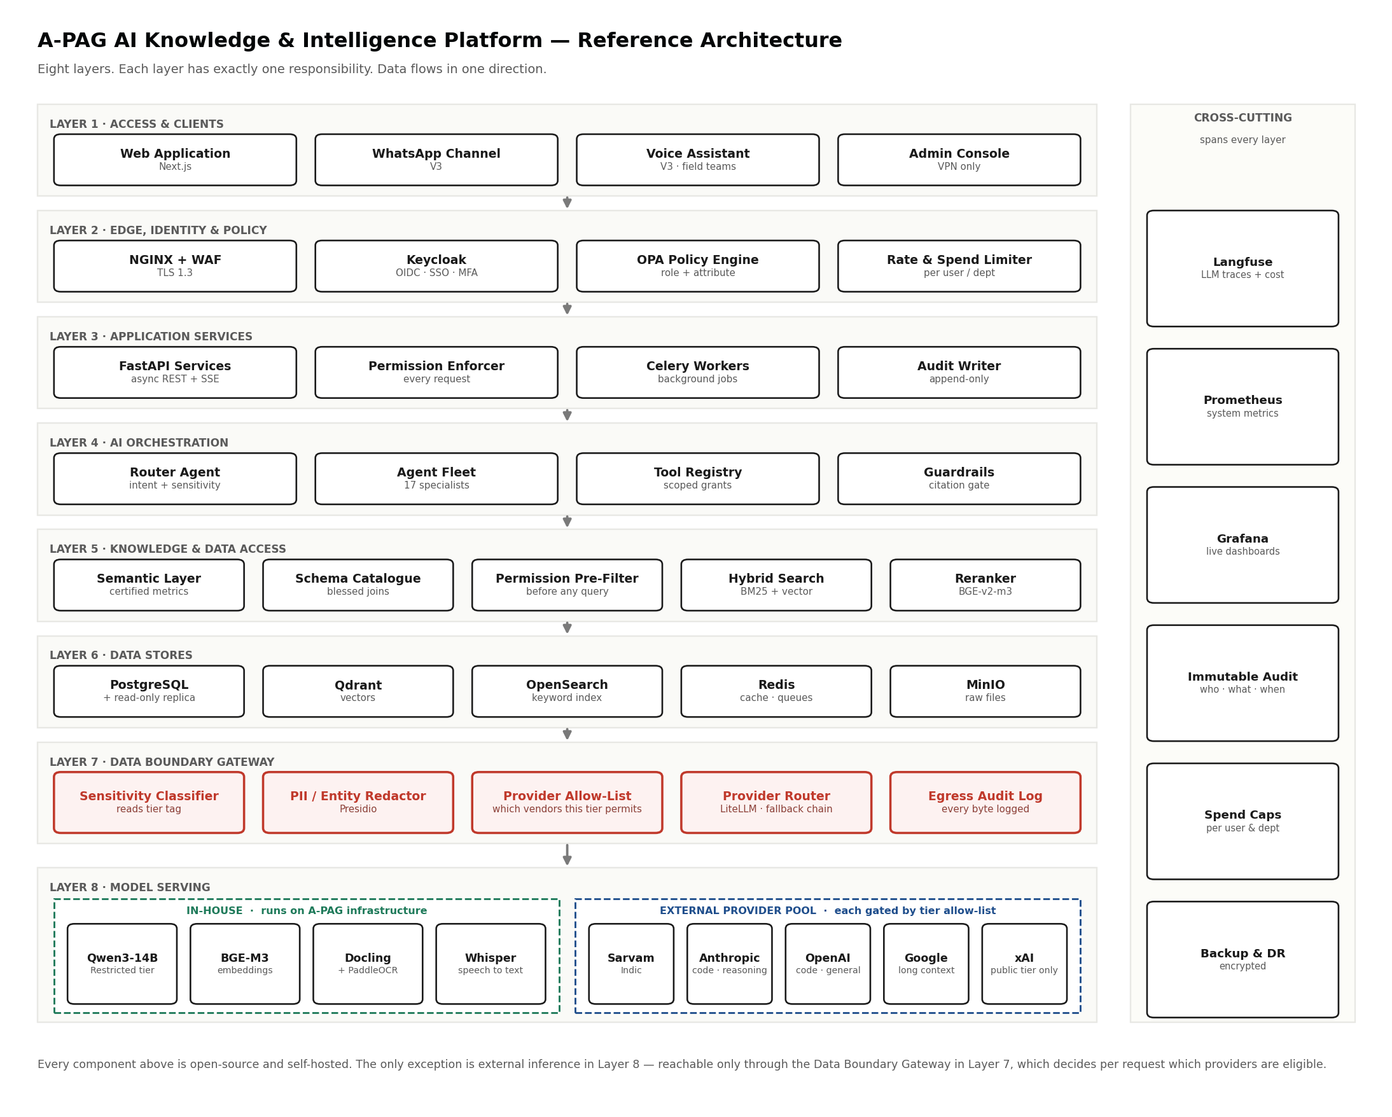
Figure 2 The reference architecture. Every subsequent chapter highlights one layer of this diagram.

Layer | Single responsibility | Chapter
1 Access & Clients | Renders chat, workspaces and the surviving dashboards. Calls the API only — never touches a database. | 2, 16
2 Edge, Identity & Policy | Authenticates the person and resolves what they are permitted to do. | 6
3 Application Services | Enforces permission on every request, runs business logic, queues background work, writes audit. | 8
4 AI Orchestration | Classifies each request, routes it to one specialist, gates the result. | 11, 12, 13
5 Knowledge & Data Access | The semantic layer for numbers and hybrid retrieval for documents — both permission-filtered first. | 7, 9
6 Data Stores | Five stores, each holding only what it is designed to hold. | 14
7 Data Boundary Gateway | The only route to any language model. Classifies, redacts, decides, logs every byte that leaves. | 5
8 Model Serving | In-house models for embedding, OCR, speech and restricted content; external API for the rest. | 10

4.1 Three rules that hold across every layer
- Data flows in one direction. There is no path where a client reaches a database, and no path where an agent reaches a model except through Layer 7.
- Permission is resolved before work begins. The system does not retrieve first and filter second. Filtering second means restricted content was scored, ranked and held in memory — one bug away from being returned.
- Every layer fails closed. An undetermined classification is treated as Restricted. An unreachable permission service denies the request. A provenance check that cannot run returns no answer.

5 Classification and the Sovereignty Boundary
THE CHAPTER THE REST OF THE ARCHITECTURE IS BUILT AROUND
IN PLAIN TERMS
Everything the platform holds — every document, and every column in the database — is labelled with how sensitive it is. That label decides who can find it, which parts of the system can read it, and whether any part of it may ever leave A-PAG's network. The most sensitive category never leaves, for any user, including the CEO.

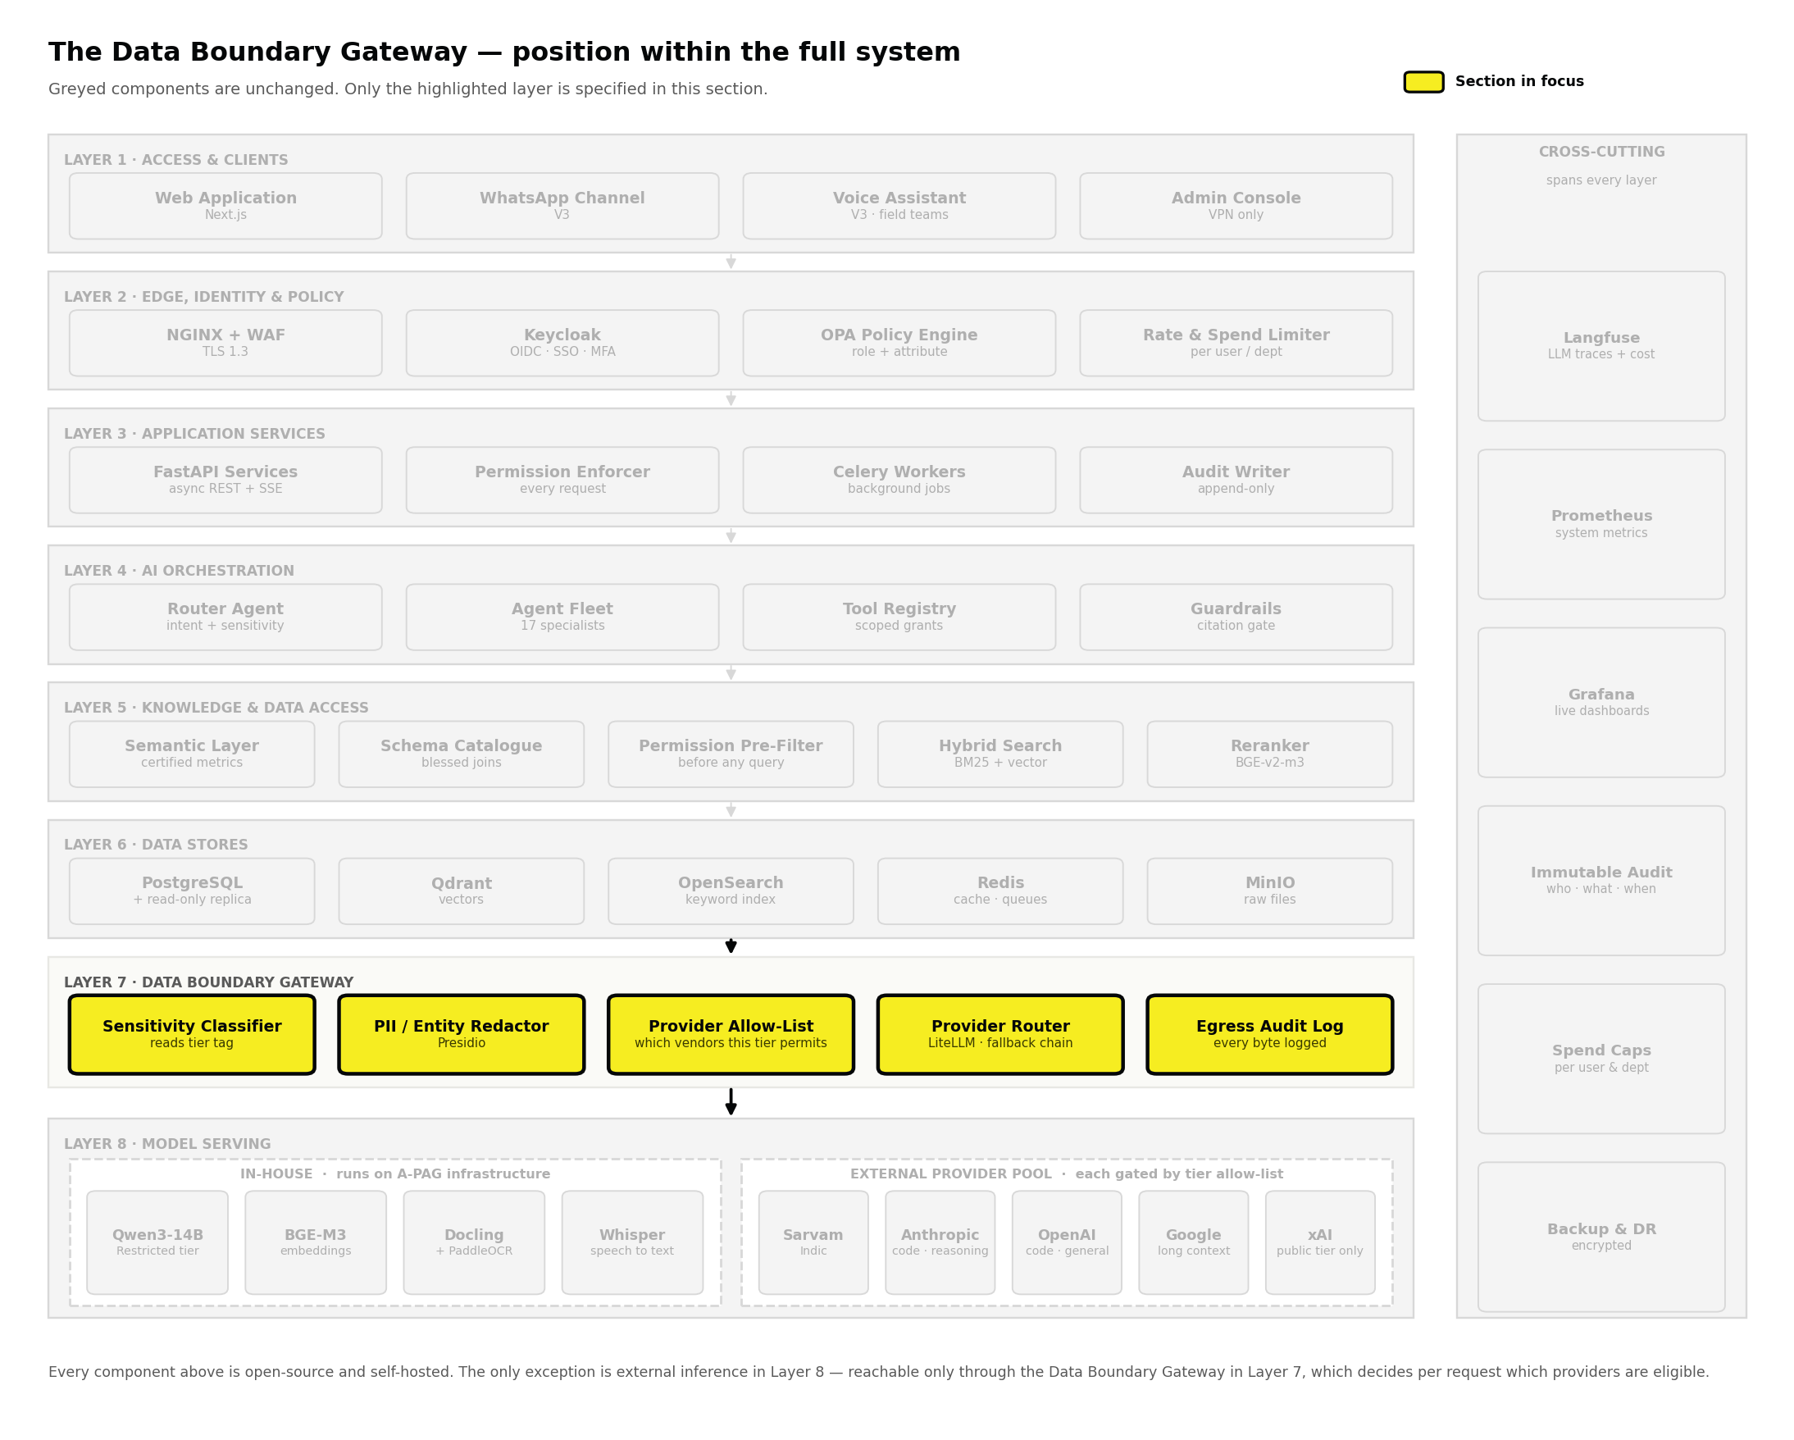
Figure 3 Every path to a language model passes through Layer 7.

5.1 Four tiers, applied to documents and to database columns
Document classification is mandatory at upload; the ingestion API rejects anything without it. Column classification is mandatory in the semantic layer; an unclassified column cannot be exposed to a query. Both are the security keystone — if content can enter unlabelled, every downstream control is guessing.

Tier | Documents | Database columns | Which providers may see it
Public | Published reports, press releases | Aggregate programme counts, public AQI readings | Any approved provider, redacted
Internal | Working documents, analysis, SOPs | Departmental budgets, deliverable status | Any provider under a signed zero-retention agreement, redacted
Confidential | Government correspondence, unpublished drafts | Grant amounts, supplier rates, staff-level costs | India-resident endpoints only, tokenised
Restricted | Donor financials, HR records, legal matters | Donor identity, individual salary, beneficiary personal data | None. In-house model only.

5.2 How the boundary is enforced
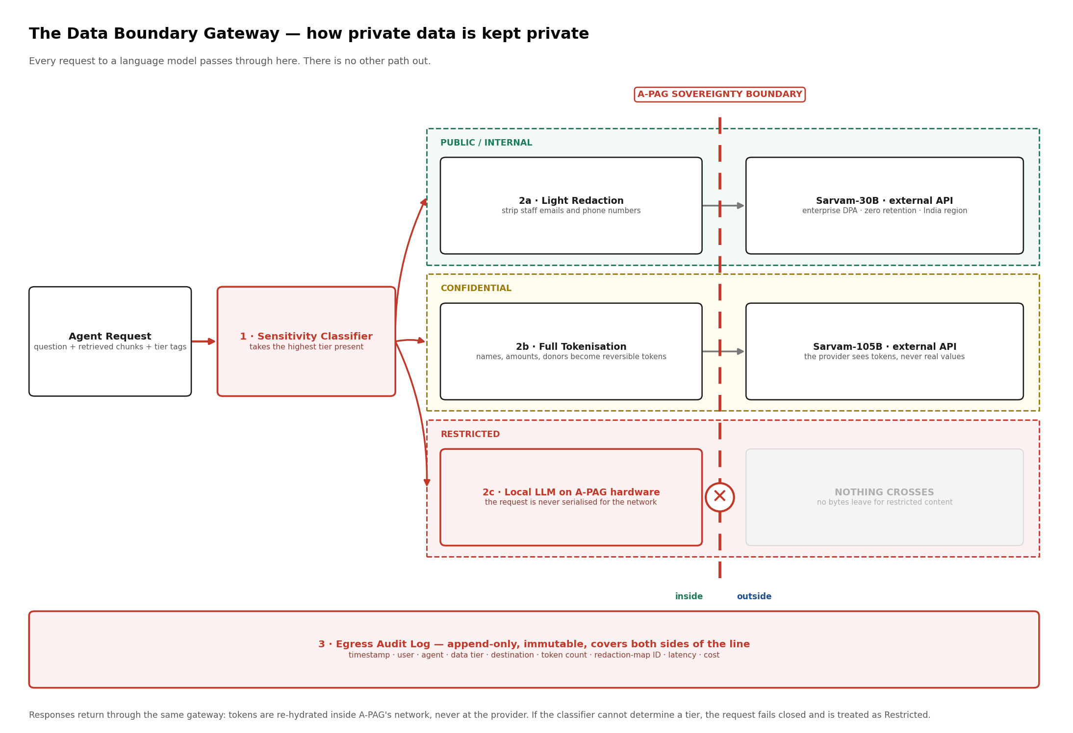
Figure 4 Three lanes, one audit log, one line that restricted content never crosses.

Classify the request, not the item
A single answer may draw on eight passages from six documents, or a result set spanning four columns. The gateway takes the highest tier present across all of them. Seven Internal passages and one Restricted passage is a Restricted request. There is no averaging and no majority rule.

Redact, tokenise, or refuse
- Public and Internal — light redaction. Staff emails, phone numbers and personal identifiers are stripped using Microsoft Presidio before the request is serialised.
- Confidential — reversible tokenisation. Names, organisations and amounts become opaque tokens (PERSON_A7, AMOUNT_C3) held in a mapping that never leaves the network. The external model reasons over structure, not identities; the mapping is reversed inside A-PAG when the response returns.
- Restricted — no egress. The request is never serialised for the network. It is handled by a model on A-PAG's own hardware. No configuration flag, environment variable or administrator role permits otherwise.

Log everything, both sides of the line
Every transaction writes an append-only record: timestamp, user, agent, tier, destination, token count, redaction-map identifier, latency and cost. When a government reviewer asks whether a particular draft was ever exposed to an external provider, the answer is a query, not an opinion.

FAIL CLOSED, ALWAYS
If the classifier cannot determine a tier — corrupt metadata, an unexpected file type, a service timeout — the request is treated as Restricted and handled in-house. The system degrades to slower and more private, never to faster and more exposed.

5.3 What this protects against, and what it does not
An architecture document that only lists strengths is a sales document. These are the honest limits.

Protects against | Does not protect against
A hosted provider retaining, training on, or being compelled to disclose sensitive content — because it never reaches them. | A cleared user reading what they are entitled to read and then acting improperly. That is an HR matter, not an architectural one.
An engineer accidentally routing restricted material outward, because the code path does not exist rather than being disabled. | A document or column classified incorrectly. Tier suggestion is automated; confirmation is human, and humans err. Section 5.4 is the mitigation.
A ranking or filtering bug surfacing content to the wrong user, because permission is applied before scoring. | Compromise of an authorised user's credentials. MFA and the audit log reduce the blast radius; they do not eliminate it.
Silent scope creep in what is sent outward, because every byte crossing the boundary is counted and reviewable. | A determined insider with administrative access. Append-only logging makes such action detectable rather than impossible.

5.4 The provider allow-list
A-PAG uses several inference providers rather than one, because no single vendor is best at every task and single-vendor dependence is itself a risk. That makes the allow-list the control that matters: for every request, the gateway resolves which providers are eligible for that data tier, and the router may choose only from that set. A provider that has not been approved for a tier is not a fallback option, an override, or a configuration setting — it is simply absent from the list the router is given.

Before a provider is added to any tier above Public | Evidence required
Zero retention of prompts and outputs | Written enterprise terms, not a marketing page
No training on A-PAG's data | Written enterprise terms
Processing region | Named region, confirmed for the specific endpoint being used — not the vendor's general availability
Sub-processor disclosure | Current list, with notification obligations on change
Deletion and incident commitments | Contractual, with defined timelines

Approval is per tier and per endpoint, and is re-confirmed annually. A provider approved for Internal is not thereby approved for Confidential; moving it up a tier is a decision requiring the same evidence again.

5.5 Reclassification and drift
- The ingestion agent proposes a tier; a human with the CLASSIFY scope confirms or overrides it. The system never publishes its own guess.
- Any change is a logged event with old tier, new tier, actor and reason. Downgrades additionally require a second approver.
- A quarterly report lists every document and column unreviewed for twelve months, and every downgrade in the period.

6 Identity, Roles and Access Control
READ, CHAT AND WRITE ARE THREE DIFFERENT RIGHTS
IN PLAIN TERMS
Everyone can log in, read what their role allows, and ask questions. Almost nobody can change what the system knows. Adding documents, changing a sensitivity label, approving a publication and managing users are separate rights, granted individually — not a package that arrives with a job title.

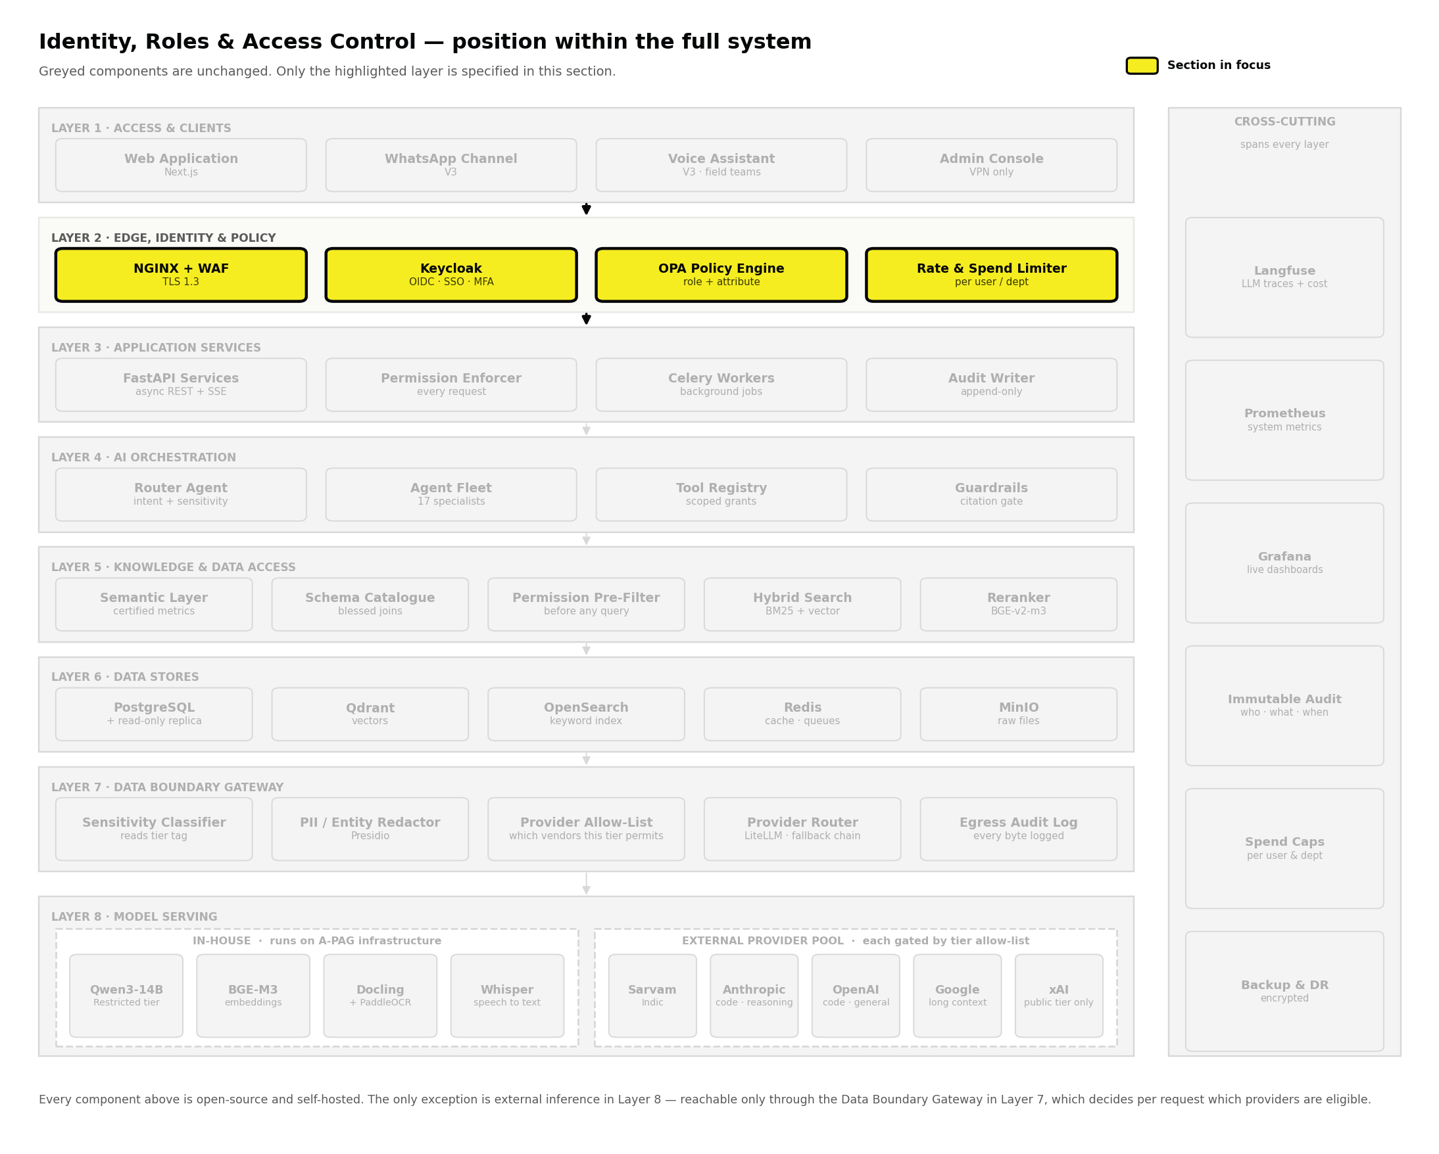
Figure 5 Identity and policy sit in Layer 2, ahead of every other layer.
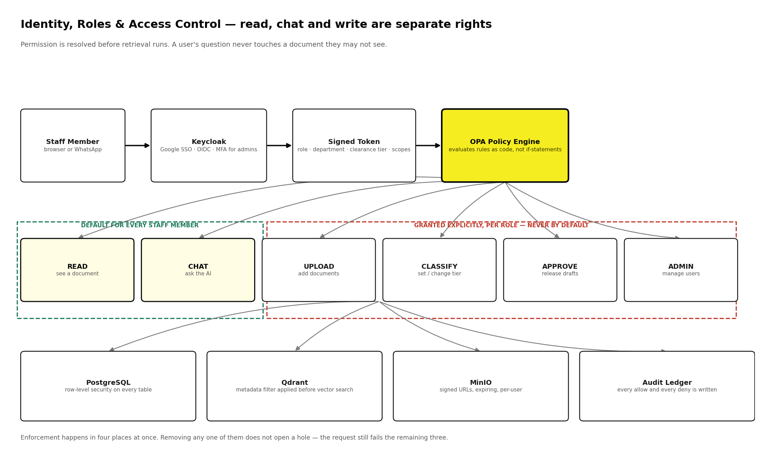
Figure 6 Read and chat are the default. Every write-type right is granted explicitly.

6.1 Six scopes

Scope | What it allows | Default
READ | Open a document, or see a query result, within the user's tier and department | Every staff member
CHAT | Ask the platform questions and receive answers within the same permissions | Every staff member
UPLOAD | Add new documents to the knowledge base | Granted per role
CLASSIFY | Set or change a document tier or a database column tier | Per role; downgrades need a second approver
APPROVE | Release a [DRAFT] report or publication, or bless a new certified metric definition | Named individuals only
ADMIN | Manage users, roles, integrations and configuration | IT team only, VPN and MFA

6.2 Role and permission matrix
Implemented as policy rules in Open Policy Agent, which makes them version-controlled, testable and reviewable as code rather than scattered through the application as conditional statements.

Role | Read | Chat | Upload | Classify | Approve | SQL | Export | Admin
Board member | ◑ | ● | – | – | – | – | ◑ | –
CEO / CEO Office | ● | ● | ● | ● | ● | ● | ● | –
Department head | ◑ | ● | ● | ● | ◑ | ● | ● | –
Researcher / Analyst | ◑ | ● | ● | – | – | ● | ◑ | –
Field officer | ◑ | ● | ● | – | – | – | – | –
Communications officer | ◑ | ● | ● | – | – | – | ◑ | –
Fundraising officer | ◑ | ● | ● | ◑ | – | ● | ◑ | –
Accounts officer | ◑ | ● | ● | ◑ | – | ● | ◑ | –
HR officer | ◑ | ● | ● | ● | – | – | ◑ | –
IT administrator | – | ● | – | – | – | – | – | ●
External auditor (time-boxed) | ◑ | – | – | – | – | – | ◑ | –

● full ◑ within the user's department and tier only – not granted

TWO DELIBERATE ENTRIES
The IT administrator has ADMIN but not READ. Whoever runs the servers should not be able to browse donor financials as a side effect of doing their job. Any override is a logged, two-person action.
A board member can chat but cannot upload or export freely. Oversight does not require the ability to change the record.

6.3 Four independent enforcement points

Point | Mechanism
Application layer | Every request is evaluated against the OPA policy set before any handler runs. A denied request never reaches business logic.
Relational database | PostgreSQL row-level security is attached to the tables themselves — on the primary and on the read-only replica the data agent queries.
Vector store | Qdrant payload filters are applied as part of the search call, so restricted passages are excluded from candidate generation.
Object storage | MinIO issues short-lived signed URLs scoped to one user and file. A copied link expires; it does not become a permanent door.
Removing any one of these does not open a hole — the request still fails the remaining three.

6.4 The write path
- Every write — upload, edit, reclassification, approval, metric definition — is recorded in an append-only ledger with actor, timestamp, before-state and after-state. No application role, including administrators, can edit it.
- Classification downgrades, external publication and new certified metric definitions each require two distinct people.
- Bulk operations over fifty items require additional confirmation and are reported to the Technology Lead the same day.
- Deletion does not exist as a user-facing operation. Items are superseded or archived; originals remain recoverable for audit.

7 Conversational Data Access — Text to SQL
PILLAR 1 · FIRST USERS LIVE 23 OCTOBER 2026
IN PLAIN TERMS
A staff member types a question about A-PAG's own numbers and gets the answer in seconds. The system does not guess. It translates the question using a curated dictionary of approved metric definitions, checks the resulting query before running it, runs it with the asker's own permissions on a copy of the database that cannot be modified, and shows the query next to the answer so anyone can check the working.

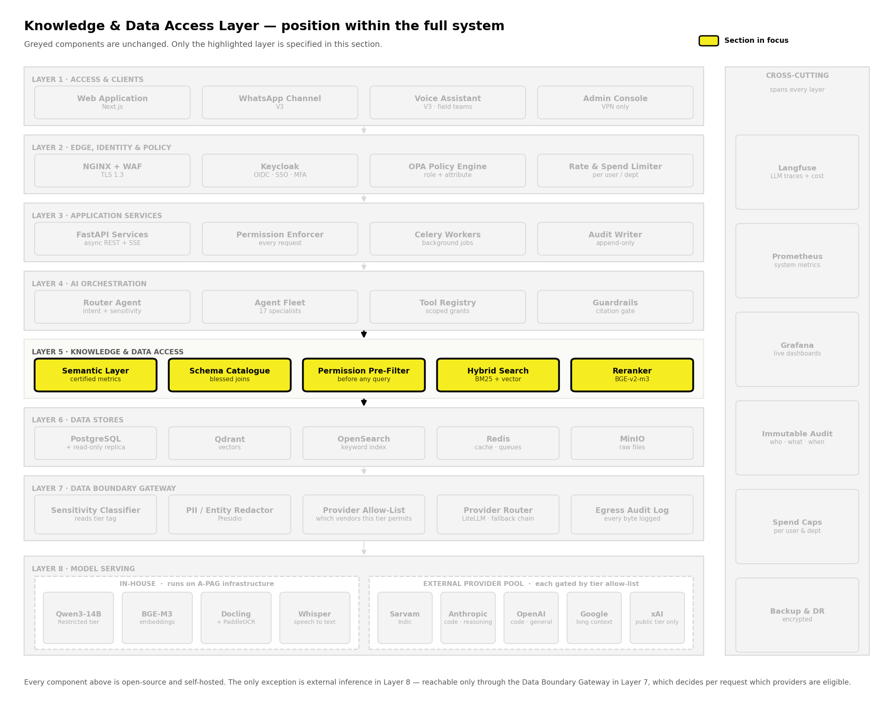
Figure 7 The semantic layer sits in Layer 5, alongside document retrieval.
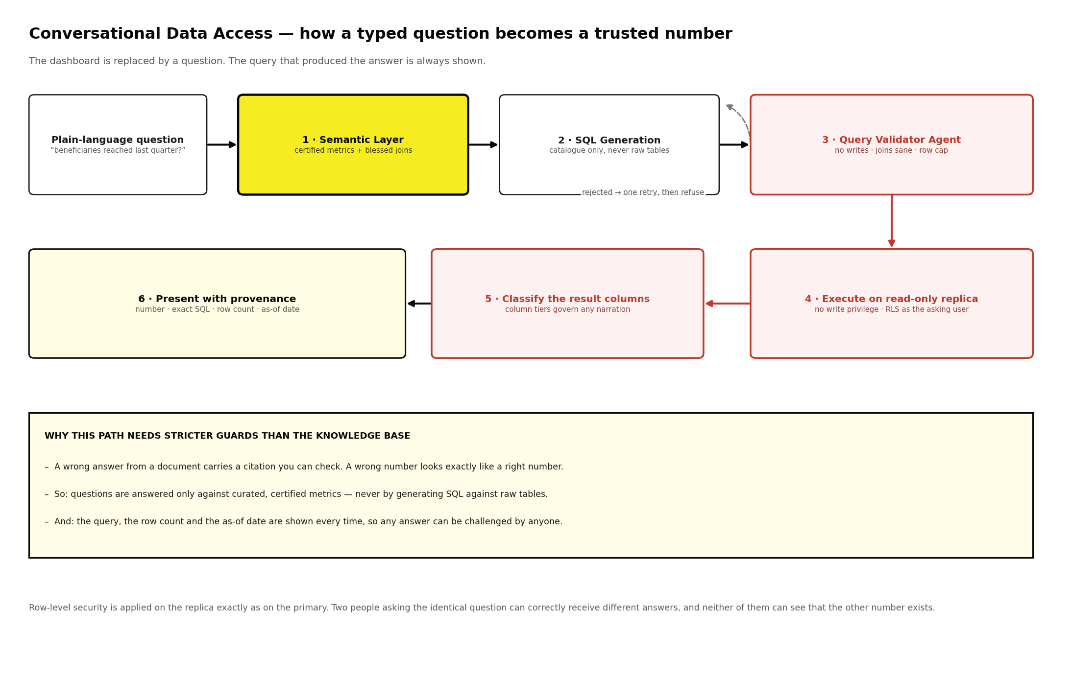
Figure 8 From typed question to trusted number, with provenance at every step.

7.1 The semantic layer is the product
The most common way text-to-SQL projects fail is by pointing a model at raw tables. The model invents plausible joins, silently picks the wrong date column, and returns a number that looks correct. Nobody catches it, because a wrong number is indistinguishable from a right one.
The semantic layer prevents this by standing between the question and the database. It is a curated, version-controlled definition of what A-PAG's data means, and the query generator is permitted to use nothing else.

Element | What it holds | Who owns it
Certified metrics | One approved definition per metric — 'beneficiaries reached' has exactly one formula, agreed once and reused everywhere | Department head, blessed by CEO Office
Blessed joins | The permitted relationships between tables, so the generator cannot invent a join that double-counts | Technology Lead
Business vocabulary | The words staff actually use, mapped to columns — 'the Punjab programme', 'last quarter', 'stubble season' | Department head
Column classification | The sensitivity tier of every exposed column, governing whether results may cross the boundary | Department head; second approver on downgrade
As-of metadata | When each source table was last refreshed, surfaced with every answer that uses it | Automatic

7.2 The six steps

Step | What happens | What stops a wrong answer
1 Interpret | The question is resolved against the business vocabulary and matched to certified metrics | A question matching no certified metric is refused, not approximated
2 Generate | SQL is written against the catalogue — never against raw tables | The generator cannot reference an unblessed table or join
3 Validate | The Query Validator Agent inspects the query before execution | Writes, deletes, unbounded scans and unblessed joins are rejected outright
4 Execute | The query runs on the read-only replica with row-level security applied as the asking user | The connection has no write privilege; two users can correctly get different answers
5 Classify | Result columns are checked against their tiers | A Restricted column means narration runs in-house, or is withheld
6 Present | Number, exact SQL, row count, as-of date and certified-metric badge shown together | Any answer can be challenged by anyone, with no ticket to the IT team

WHY THIS PATH CARRIES STRICTER GUARDS THAN THE KNOWLEDGE BASE
A wrong answer from a document arrives with a citation you can check in ten seconds. A wrong number arrives looking exactly like a right number, gets pasted into a donor report, and is discovered months later by someone else. That asymmetry is why generation is confined to certified metrics, why a separate agent validates every query before execution, and why provenance is displayed rather than available on request.

7.3 What it will not do
- It will not answer a question that maps to no certified metric. It says so, and offers to route the request to the department head who can define one.
- It will not write, update or delete anything. Those privileges are absent from the database connection, not merely restricted by policy.
- It will not join across departments a user cannot see in both. Row-level security applies per table, so a partially permitted join returns a partial answer with that fact stated.
- It will not silently substitute a similar metric. 'Beneficiaries reached' and 'beneficiaries registered' are different certified metrics and are never interchanged.

7.4 Retiring dashboards, in sequence
Dashboards are retired in Phase 2 — late October to November 2026 — after the conversational path has been live long enough to trust, and in a specific order.
- Instrument the existing dashboards for one month to find which views are actually opened, and by whom.
- Retire views with no weekly users first — pure maintenance cost, and usually already stale.
- For views with users, confirm the equivalent question returns the same number before retiring the view. A discrepancy is a semantic-layer defect and must be fixed, not explained away.
- Keep roughly five canonical standing boards. A question asked every morning should not require typing.

8 The Document Pipeline
PILLAR 2 FOUNDATION · BUILT IN PHASE 3, DEC 2026
IN PLAIN TERMS
The conveyor belt that turns an uploaded file into something the system can answer questions from. Eight steps, visible status throughout, and a fourth step — applying a sensitivity label — that cannot be skipped.

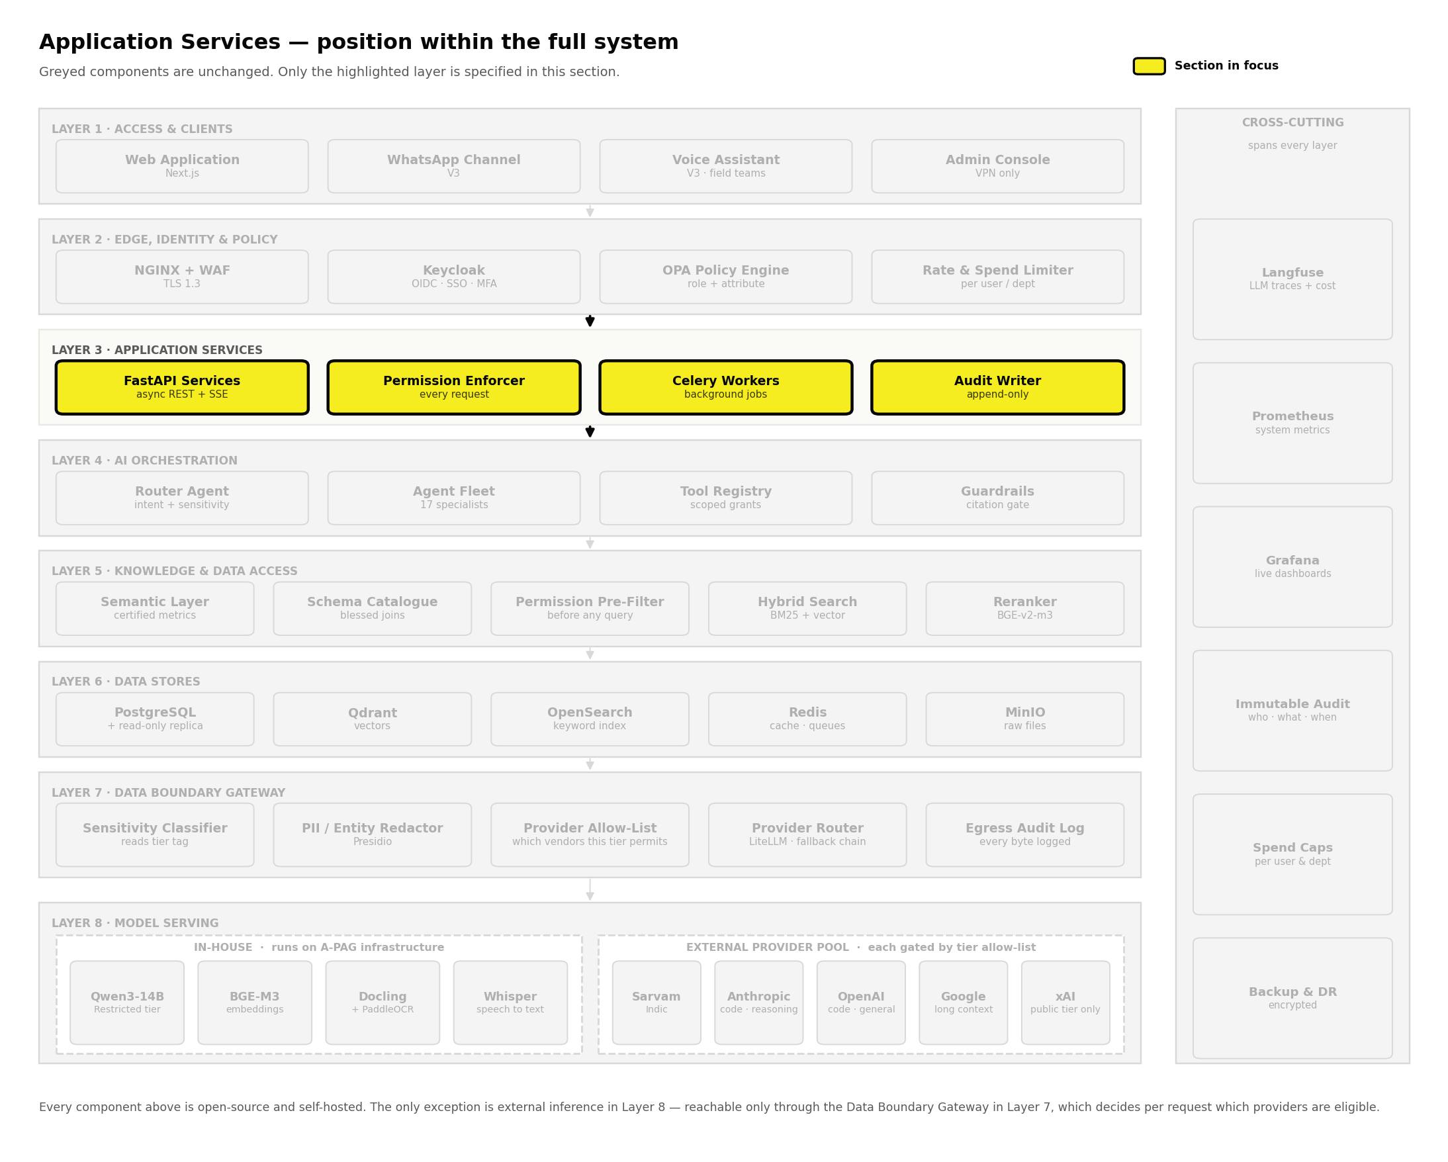
Figure 9 The pipeline runs on background workers in Layer 3, so nobody waits at a loading screen.
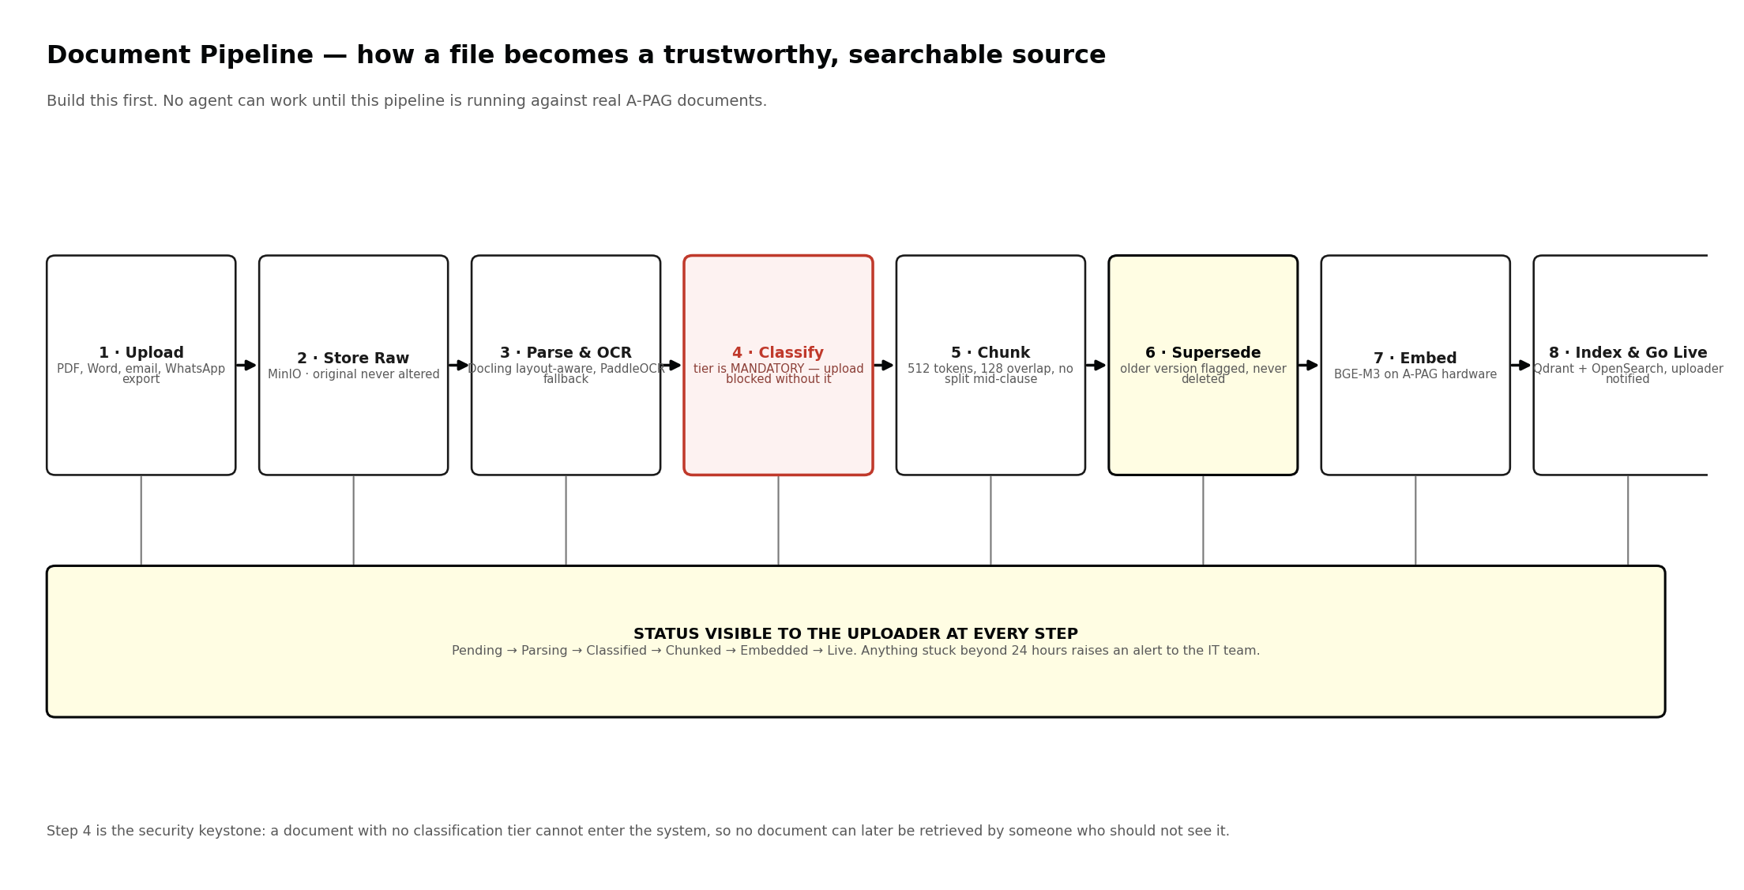
Figure 10 Eight steps from upload to live. Step 4 is the security keystone.

Step | What happens | Component
1 Upload | File arrives via the ingestion API, email connector or WhatsApp export parser; type and size validated. | FastAPI
2 Store raw | The original is written to object storage and never modified. | MinIO
3 Parse and OCR | Layout-aware extraction preserves tables, headings and clause structure; scans fall back to OCR. | Docling, PaddleOCR
4 Classify | Metadata extracted, tier proposed by the model and confirmed by a human. Upload is blocked without one. | Ingestion Agent
5 Chunk | Split into roughly 512-token passages with 128-token overlap, respecting clause boundaries. | LangChain splitters
6 Supersede | An existing document with the same reference is flagged Superseded — retained for audit, never deleted. | PostgreSQL
7 Embed | Passages converted to searchable form on A-PAG's own hardware. Nothing leaves the network here. | BGE-M3
8 Index | Vectors to Qdrant, text to OpenSearch, both pre-tagged with department and tier. Status becomes Live. | Qdrant, OpenSearch

8.1 Chunking policy
Chunk size is a quality decision disguised as a technical one. Too small loses the context that makes a clause meaningful; too large dilutes the sentence that answers the question. This is the starting point, to be tuned against real A-PAG documents during Phase 3.
- Never split inside a numbered clause, a table row or a bulleted item. Structure beats size.
- Each passage carries its page number and section heading, so a citation points to the exact place in the original.
- Tables are extracted as structured records in addition to text — a table rendered as prose is unusable for a factual question.

8.2 Key data entities

Entity | What it holds
Document | Identifier, storage URL, title, author, date, department, tier, status, supersedes-identifier, checksum
Chunk | Document identifier, index, text, page, section heading, tier tag, department tag, embedding vector
Chat session | Every question, answer, agent used, passages cited or query run, token cost
Audit event | Actor, action, object, before-state, after-state, timestamp — append-only, no update or delete path
Classification event | Item, old tier, new tier, actor, second approver where required, reason, timestamp

9 Knowledge and Retrieval
FINDING THE RIGHT PARAGRAPH, NOT THE RIGHT DOCUMENT
IN PLAIN TERMS
Finding a document is not the hard part; finding the paragraph inside it that answers the question is. The system searches two ways at once — one matching exact words like an order number, one matching meaning even across languages — then combines and re-ranks the results.

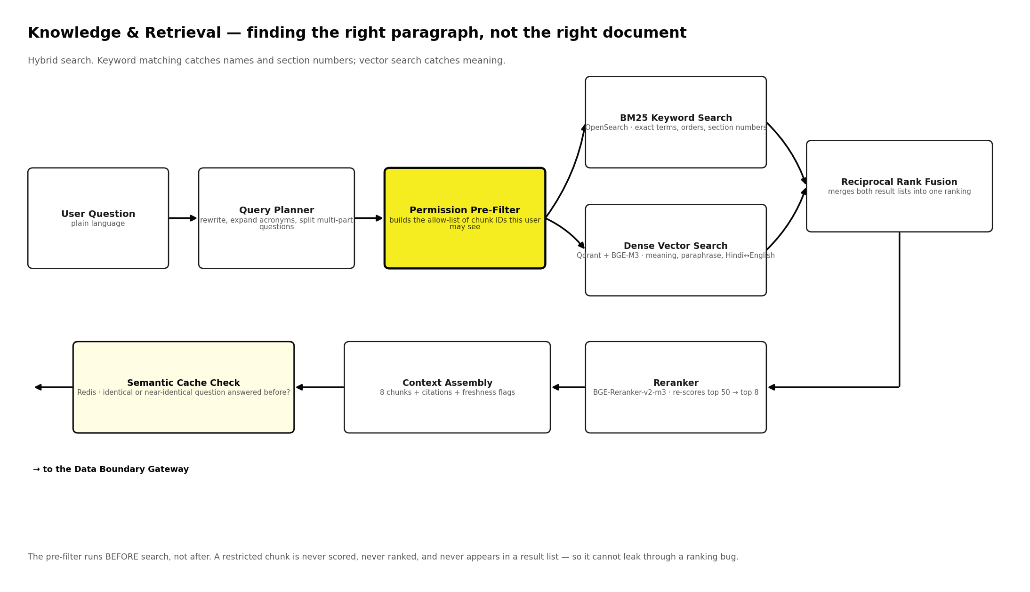
Figure 11 Hybrid retrieval. The permission filter runs before search, not after.

Method | Good at | Misses on its own
Keyword (BM25, OpenSearch) | Exact terms: order numbers, section references, named schemes, acronyms | Questions phrased differently from the source; synonyms; paraphrase
Dense vector (Qdrant + BGE-M3) | Meaning: paraphrase, conceptual similarity, Hindi–English cross-matching | Precise identifiers — a vector search for 'Order 47 of 2024' can return Order 48
Both, fused | Recall from the vector side, precision from the keyword side | Nothing structural — this is what the platform uses

9.1 Permission filtering happens first
The allow-list of passages the user may see is constructed before any search executes, and passed into both engines as a hard filter. The alternative — searching everything and filtering results — is common, faster to build, and wrong: it means a restricted passage was retrieved, scored, ranked and held in memory. Filtering afterwards protects against nothing except the absence of bugs.

9.2 Reranking, freshness and caching
- Fusion produces roughly fifty candidates; a reranking model scores each against the question and keeps the best eight. This runs on A-PAG's own hardware.
- Passages older than two years are flagged, and any answer relying on one carries a visible freshness warning.
- A superseded document appearing alongside its replacement is dropped. Two versions of the same policy can never be cited together.
- Repeated questions are served from a semantic cache scoped by permission set — two users with different clearances never share a cached answer. Any correction invalidates every entry derived from the affected document immediately.

10 Multi-Provider Model Routing
MANY PROVIDERS · THREE GATES · ONE AUDITED PATH OUT
IN PLAIN TERMS
The platform does not depend on one AI vendor. It uses several, and picks between them for each request. Three questions decide, always in this order: how sensitive is the material, what capability does the job actually need, and which of the remaining options is cheapest. Sensitivity is asked first because a cheaper or weaker answer is acceptable and a leaked document is not.

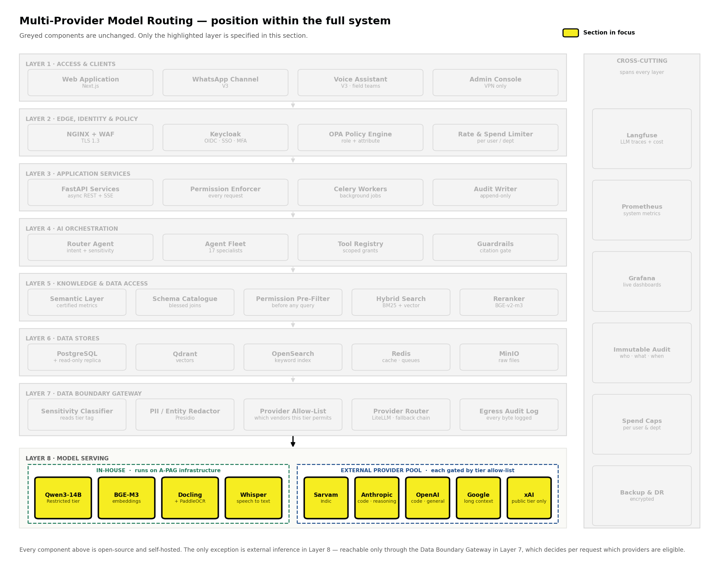
Figure 12 The provider pool is Layer 8, reachable only through the gateway in Layer 7.
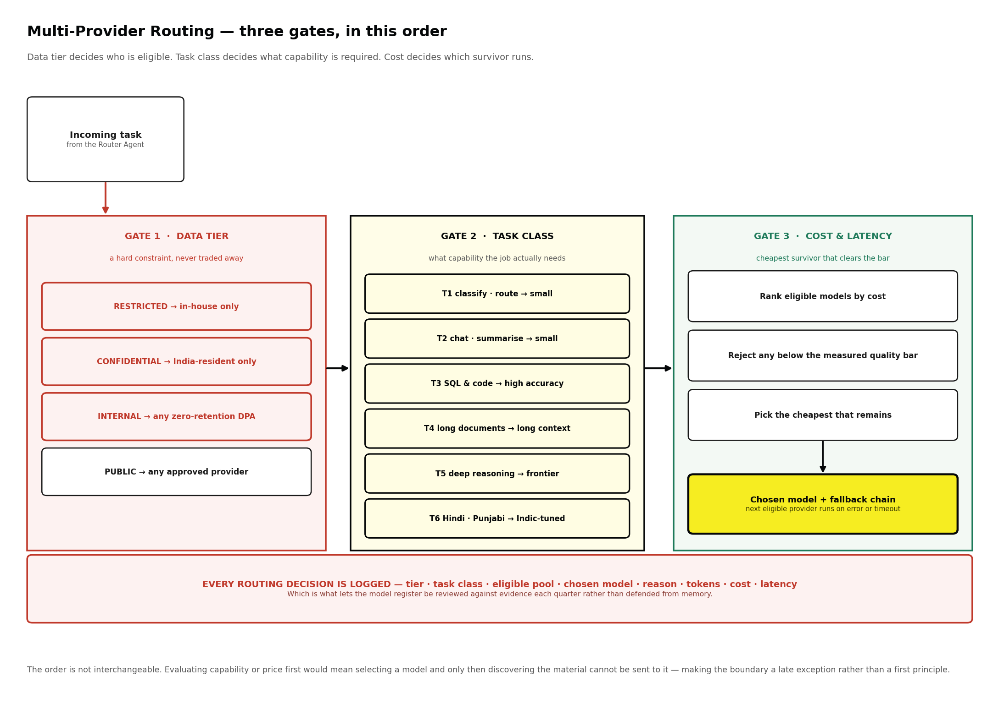
Figure 13 Three gates. The order is not interchangeable.

10.1 Why several providers rather than one
- No vendor leads everywhere. Strength in code and structured generation, in very long context, in Indian-language fluency and in cheap high-volume classification currently sit with different providers, and the ranking changes every few months.
- Single-vendor dependence is a commercial risk. One provider's pricing change, rate limit, outage or terms revision should not be able to stop A-PAG working.
- Cost falls sharply with routing. The majority of platform traffic is classification, tagging and short answers. Sending that to a frontier model is the single largest avoidable cost in a system like this.
- But every added provider is another egress path. That is the cost of this choice, and it is paid for with the allow-list in Chapter 5.4 and the logging in Section 10.5 — not with goodwill.

10.2 Gate 1 — data tier decides who is eligible
This gate is a hard constraint and is evaluated before anything else is considered. Its output is a list of permitted providers; the later gates may only choose from that list.

Tier | Eligible pool | Treatment before the request leaves
Restricted | In-house only — no external provider is eligible under any condition | Nothing leaves. The request is never serialised for the network.
Confidential | India-resident endpoints only, from providers approved at this tier | Full reversible tokenisation; the mapping never leaves A-PAG's network
Internal | Any provider holding a signed zero-retention agreement | Personal identifiers redacted
Public | Any approved provider | Light redaction

10.3 Gate 2 — task class decides what capability is required
Task classes are stable even as models change. The register in Section 10.4 maps classes to current models; the classes themselves should not need revising.

Class | Work it covers | Capability required
T1 | Intent classification, routing, tagging, metadata extraction | Small and fast. Volume is high and difficulty is low.
T2 | General chat, summarisation, short answers over retrieved passages | Small to mid.
T3 | SQL generation, code, structured output that must be exactly right | High accuracy on structured generation. Errors here are silent and expensive.
T4 | Synthesis across many long documents; board and donor reports | Large context window and strong long-range coherence.
T5 | Regulatory interpretation, obligation extraction, contradiction detection | Frontier reasoning.
T6 | Hindi and Punjabi content, translation, field material | Indic-tuned.
T7 | Embedding, reranking, document parsing, speech to text | In-house always. Never routed externally.

10.4 The model register
This is the register as proposed at signing. It is expected to change: model families are revised every few months, and the register is reviewed quarterly against the evaluation harness in Section 10.6. What must not change without a decision is the tier eligibility in the third column.

Class | Preferred | Fallback | Tier ceiling
T1 classify, route, tag | Cheapest small model in the eligible pool — typically a Gemini Flash or GPT-mini class model | Sarvam-30B | Internal
T2 chat, summarise | Claude Sonnet class or Sarvam-30B, whichever is cheaper at required quality | Gemini Pro class | Confidential, if the endpoint is India-resident
T3 SQL and code | Claude Sonnet or Opus class; OpenAI Codex-class models as the alternate | Gemini Pro class | Confidential, if India-resident
T4 long-document synthesis | Gemini Pro class for very large context; Claude Opus class for coherence | Sarvam-105B | Confidential, if India-resident
T5 deep reasoning, compliance | Frontier reasoning model from any approved provider | Claude Opus class | Confidential, if India-resident
T6 Hindi and Punjabi | Sarvam-30B / 105B | Gemini Pro class | Confidential
T7 embed, rerank, parse, speech | BGE-M3, BGE-Reranker-v2-m3, Docling + PaddleOCR, Whisper / IndicConformer | — | In-house only
Any Restricted content | Qwen3-14B, quantised, on A-PAG hardware | Gemma 3-12B, if its licence terms are accepted | In-house only

TWO ENTRIES WORTH ARGUING ABOUT NOW RATHER THAN IN MONTH 6
Grok is listed as approved for Public tier only. That is not a judgement on the model — it is that its enterprise data-handling and processing-region commitments are the ones A-PAG has least documented evidence for. Raise it a tier when the written terms in Chapter 5.4 have been obtained, and not before.
Gemma appears only as an in-house fallback, never as an API. Its terms of use are not an OSI-approved open-source licence and impose usage restrictions, which is why Qwen3-14B is the primary in-house model. If leadership accepts Gemma's terms, it is a reasonable alternative; that is a decision, not a default.

10.5 Gate 3, fallbacks and the single path out
Every model call from every agent goes through one provider router — LiteLLM, self-hosted, presenting a single interface across all providers. Adding, removing or reordering a provider is a configuration change; no agent code refers to a vendor by name.
- Gate 3 ranks the surviving models by cost per token, discards any scoring below the measured quality bar for that task class, and selects the cheapest that remains.
- Each route carries an ordered fallback chain. On error, timeout or rate limit the next eligible provider runs automatically — and the fallback is drawn from the same tier-eligible pool, never from a wider one.
- If every eligible provider fails, the request fails. It does not silently fall back to a provider outside the allow-list.
- Every decision is logged: tier, task class, eligible pool, chosen model, reason, tokens, cost and latency. This is what makes the register reviewable against evidence.

10.6 The evaluation harness
Routing by quality is only honest if quality is measured. A fixed evaluation set is maintained per task class — real A-PAG questions with verified correct answers, including a numeric set for T3 where the right figure is known independently.
- The set runs against every candidate model quarterly, and against any model before it enters the register.
- Results set the quality bar used by Gate 3. A model that drops below its bar is demoted automatically, not after somebody notices.
- Results live in Langfuse on A-PAG's own infrastructure, so the evaluation history is an owned asset that survives any provider change.
- The harness is also the release gate: a regression in provenance accuracy or a numeric mismatch blocks deployment.

STATED FOR THE RECORD
Answer quality is negotiable. The sovereignty boundary is not. Where they conflict, quality loses — a hard question about a Restricted document runs on the smaller in-house model, and the user is told plainly that this is why.

11 Orchestration and the Agent Fleet
HOW A REQUEST TRAVELS THROUGH SEVENTEEN SPECIALISTS
IN PLAIN TERMS
Rather than one general assistant that does everything moderately well, the platform uses narrow specialists. A router reads each request once and hands it to exactly one of them. Every specialist's output then passes through the same final checkpoint before anyone sees it — there is no route that bypasses it.

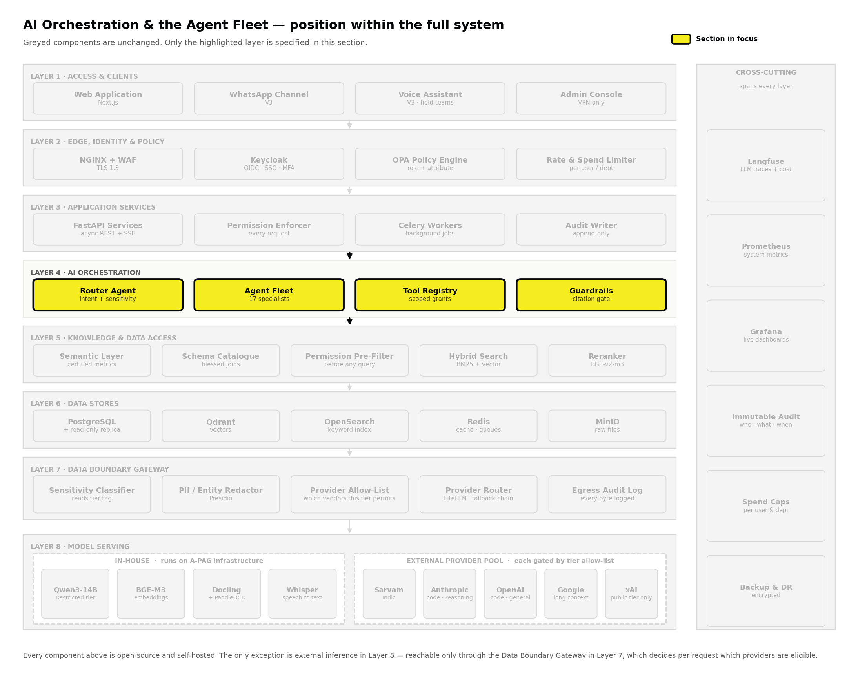
Figure 14 Orchestration is Layer 4, between the application and the data-access layer.
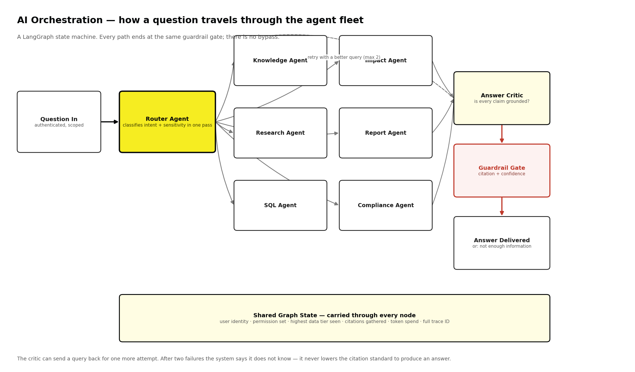
Figure 15 A state machine. Every path converges on the same guardrail gate.

11.1 Why many narrow agents rather than one broad one
- Grounding. An agent with one job and four tools stays close to its sources. An agent with twenty tools drifts, and drift in a government-facing organisation means a confidently wrong answer in a policy note.
- Diagnosability. When a specialist fails, the failure is legible — the Research Agent returned nothing because Crossref timed out. When a generalist fails, the investigation starts from scratch.
- Least privilege. Each agent holds only the tools and data access its job requires. The Publishing Agent is structurally incapable of reading a Confidential document because that tool binding does not exist for it.
- Independent evolution. A new agent is registered with the router and becomes available without modifying any existing agent. This is what lets the fleet grow from three agents at first go-live to seventeen over time, without a rewrite — and it is why the agents scheduled after handover can be added by whoever inherits the platform.

11.2 Shared graph state
Every node reads and writes one shared state object. This is what makes the security properties hold across a multi-step task rather than only at the first step.

Field carried through every node | Why it must travel with the request
User identity and full permission set | A sub-agent invoked three steps deep applies the same restrictions as the first step. Permissions are never re-derived or widened downstream.
Highest data tier encountered so far | A task that touches one Restricted passage or column becomes a Restricted task for its entire remaining lifetime, including every sub-call.
Provenance gathered so far | The guardrail gate needs the complete evidence set — citations for narrative answers, the executed query and as-of date for numbers.
Cumulative token spend | Caps apply to the whole task, not each call in isolation — otherwise a ten-step task silently costs ten times the limit.
Trace identifier | One identifier links every model call, retrieval and decision in Langfuse, which is what makes an audit answerable end to end.

11.3 Retry and refusal policy
A critic may return a draft for one further attempt with a reformulated query or a regenerated SQL statement. After two failed attempts the system states that it does not have enough information.
It does not lower the provenance threshold to produce something. A refusal is a correct output, and treating it as a failure is precisely how organisations end up with confidently wrong figures in a government submission.

12 Agent Specifications
SEVENTEEN SPECIALISTS · ONE JOB EACH
Each agent below has one purpose, a fixed tool list, a defined ceiling on what data it may see, and one guardrail. An agent whose limits cannot be drawn on a single page is an agent nobody can audit.

# | Agent | One-line purpose | Ships in
A1 | Router | Reads every request once and decides who handles it and how sensitive it is | Phase 1 · Oct 2026
A2 | Conversational Data | Turns a typed question into a trusted number | Phase 1 · Oct 2026
A3 | Query Validator | Inspects every generated query before it touches the database | Phase 1 · Oct 2026
A4 | Impact Analytics | Answers performance questions and narrates what the numbers are doing | Phase 2 · Nov 2026
A5 | Ingestion & Classification | Turns a raw file into clean, tagged, chunked, searchable knowledge | Phase 3 · Dec 2026
A6 | Knowledge | Answers strictly from A-PAG's own indexed documents | Phase 3
A7 | Answer Critic | Checks a draft narrative answer against its sources | Phase 3 · Dec 2026
A8 | Report | Assembles a structured first draft from gathered evidence | Post-handover
A9 | Research | Finds peer-reviewed external evidence, already cited | Post-handover
A10 | Compliance & Obligation | Tracks what A-PAG is obliged to do, and by when | Post-handover
A11 | Knowledge Transfer | Captures what a departing staff member knows, before access is revoked | Post-handover
A12 | External Monitoring | Watches government portals, bodies, research and news continuously | Post-handover
A13 | Internal Feed | Runs the cross-departmental notice board as permanent citable records | Post-handover
A14 | Fundraising Intelligence | Matches A-PAG's work to donor priorities; keeps proposal evidence current | Post-handover
A15 | HR Policy | Answers routine staff admin questions from the handbook | Post-handover
A16 | Publishing | Drafts outward-facing content — and cannot publish it | Post-handover
A17 | Field Capture | Turns a site-visit voice note into a structured, searchable record | Post-handover

A1 · Router Agent
Every request enters here and is classified once — which specialist should handle it, and how sensitive the subject matter is. The sensitivity decision is made before anything has been retrieved rather than after.
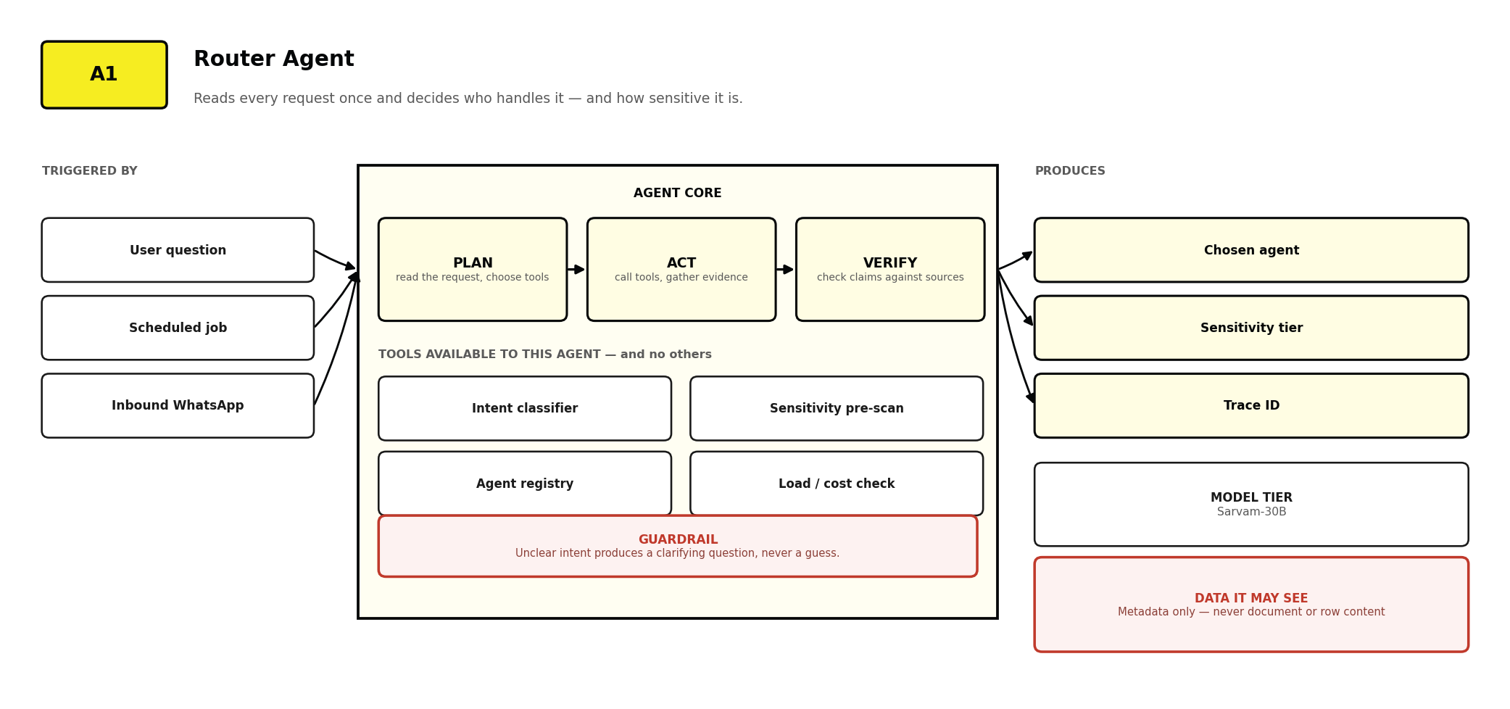
Figure 16 Router Agent — triggers, tools, model tier, data access and guardrail.
- Reads metadata and question text only. It never sees document contents or row values, which keeps the cheapest, highest-volume model on the least sensitive data.
- Ambiguous intent produces a clarifying question rather than a guess. A wrong route wastes a model call; a confident wrong route produces a wrong answer.
- A single point of failure by design, and therefore the most heavily tested component. Its decisions are logged and sampled weekly during Phase 1.

A2 · Conversational Data Agent
The V1 product. It turns a plain-language question about A-PAG's own numbers into a query, and returns the answer with the query, row count and as-of date attached.
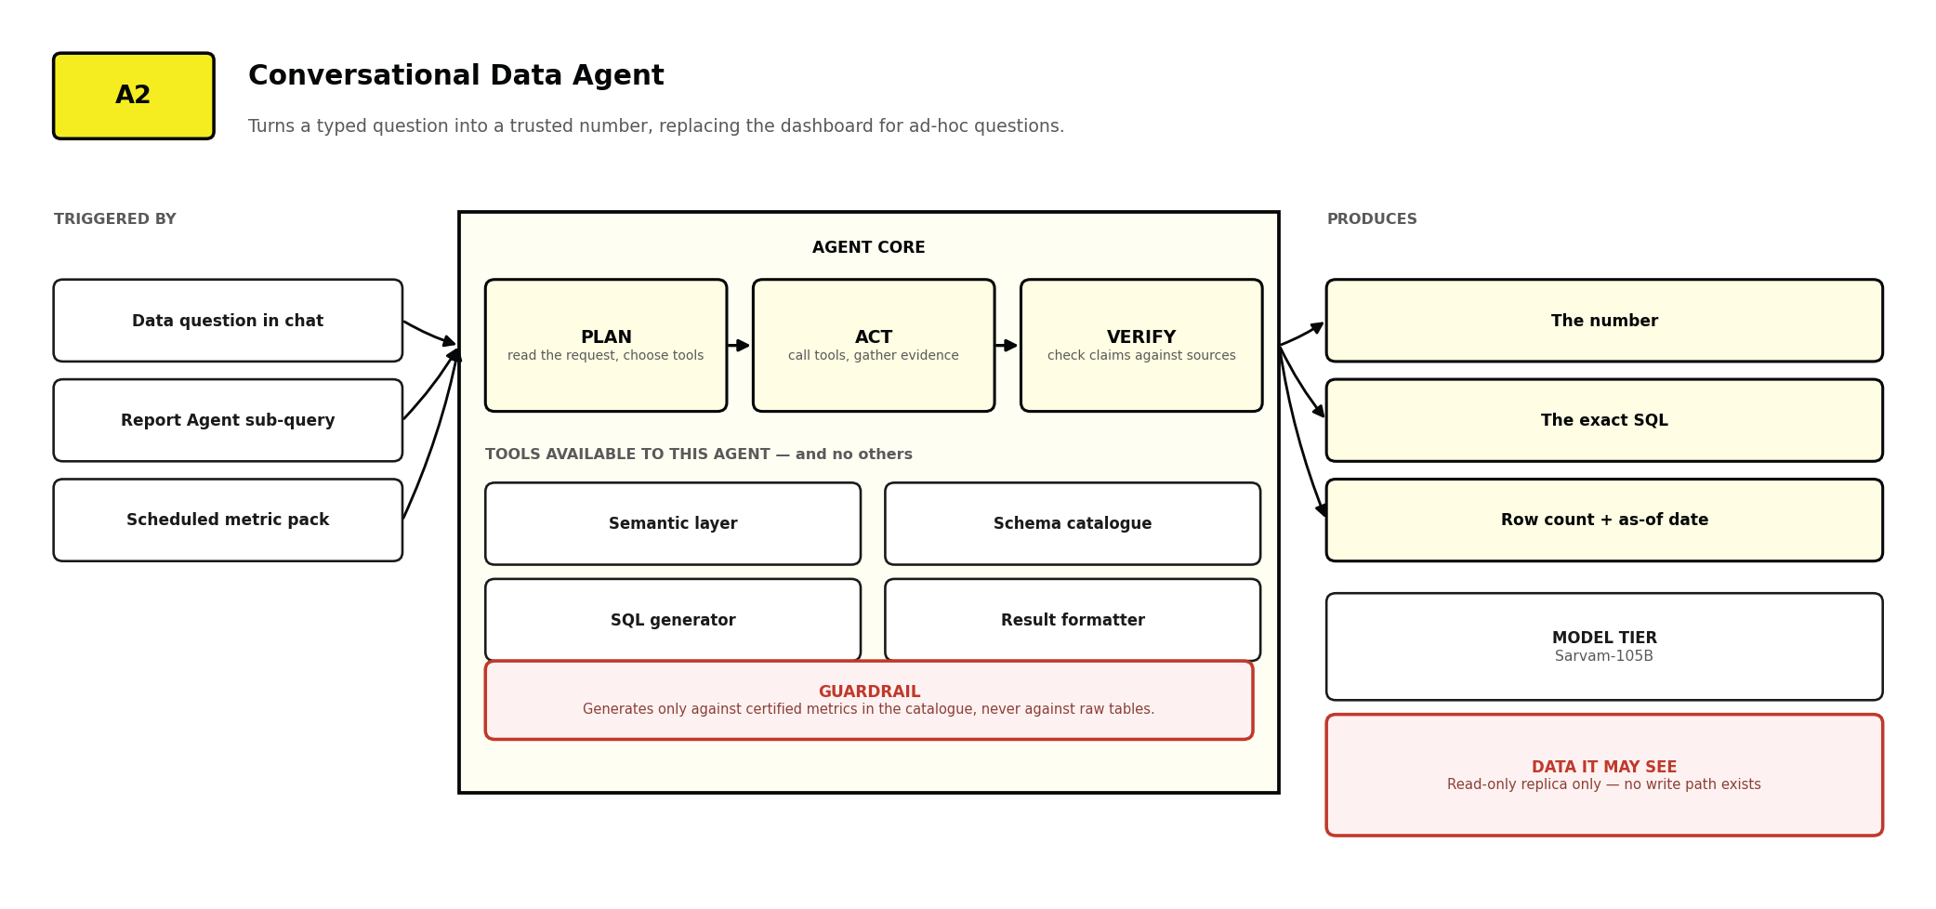
Figure 17 Conversational Data Agent — triggers, tools, model tier, data access and guardrail.
- It generates only against certified metrics in the semantic layer, never against raw tables. A question matching no certified metric is refused with an offer to route it to whoever can define one.
- It escalates to the larger model for query generation because a malformed join is far more costly than the extra tokens.
- It never substitutes a similar metric. 'Beneficiaries reached' and 'beneficiaries registered' are distinct and are never interchanged.

A3 · Query Validator Agent
The reason a wrong number does not reach a donor report. It inspects every generated query statically before execution, and has authority to reject.
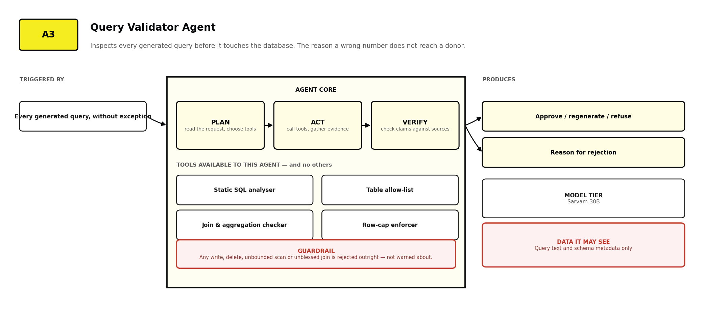
Figure 18 Query Validator Agent — triggers, tools, model tier, data access and guardrail.
- Rejection is outright, not a warning. Any write, delete, unbounded scan or unblessed join fails immediately and is regenerated once, then refused.
- It works on query text and schema metadata only, so it can run on the small, fast model and add negligible latency.
- Its rejection rate is a headline metric. A rising rate points at the semantic layer, not the model — which sends investigation to the right place.

A4 · Impact Analytics Agent
Sits above the data agent and turns figures into a narrative — what the number is, what it was, and which direction it is moving.
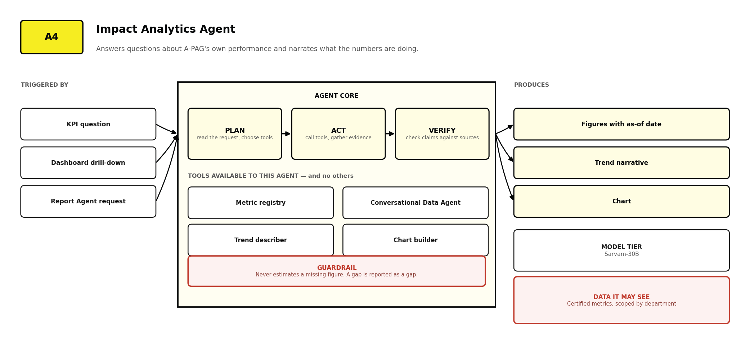
Figure 19 Impact Analytics Agent — triggers, tools, model tier, data access and guardrail.
- Every figure carries its source table and as-of date. A number without a date cannot be defended in a donor meeting.
- It never estimates or interpolates a missing figure. A gap is reported as a gap.
- It reads through the metric registry, so a definition changes in one place and every report using it changes with it.

A5 · Ingestion & Classification Agent
The only agent with write access to the knowledge base. It parses uploads, extracts metadata, proposes a tier, detects superseded versions, and produces the passages everything else depends on.
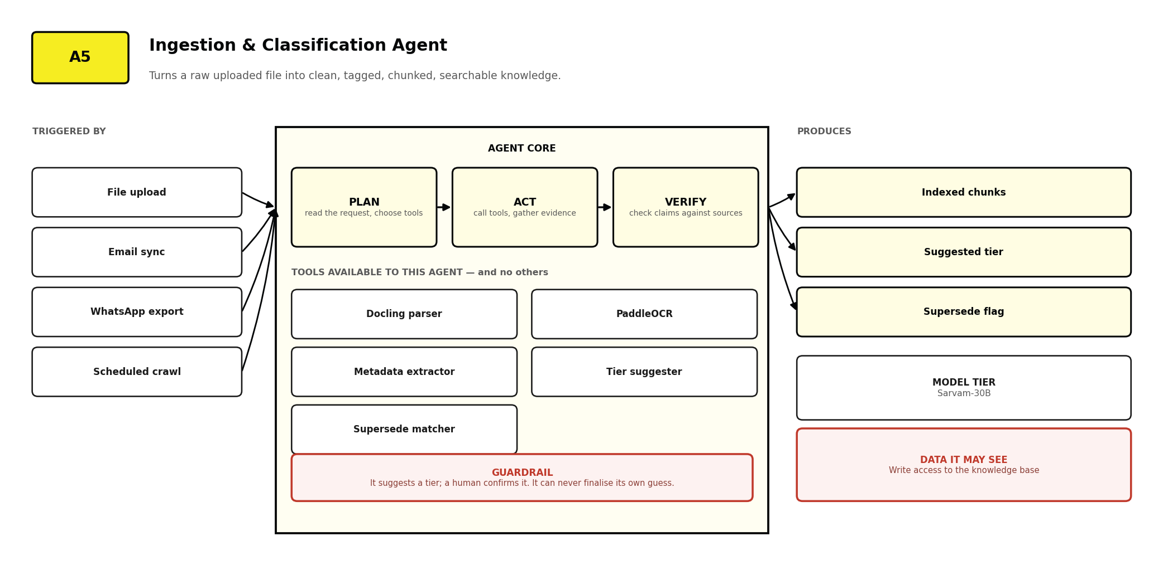
Figure 20 Ingestion & Classification Agent — triggers, tools, model tier, data access and guardrail.
- It proposes a tier; a human with the CLASSIFY scope confirms it. It can never finalise its own guess — the single most consequential guardrail in the platform.
- Supersede detection matches on reference, title similarity and issuing body, and flags rather than deletes, because audit requires the superseded copy to remain.
- Parsing failures surface as a status, never a silent skip. An unreadable document is visible in the IT queue rather than quietly absent from search.

A6 · Knowledge Agent
Answers questions using only A-PAG's own indexed documents, attaching the exact paragraph it drew on to every claim.
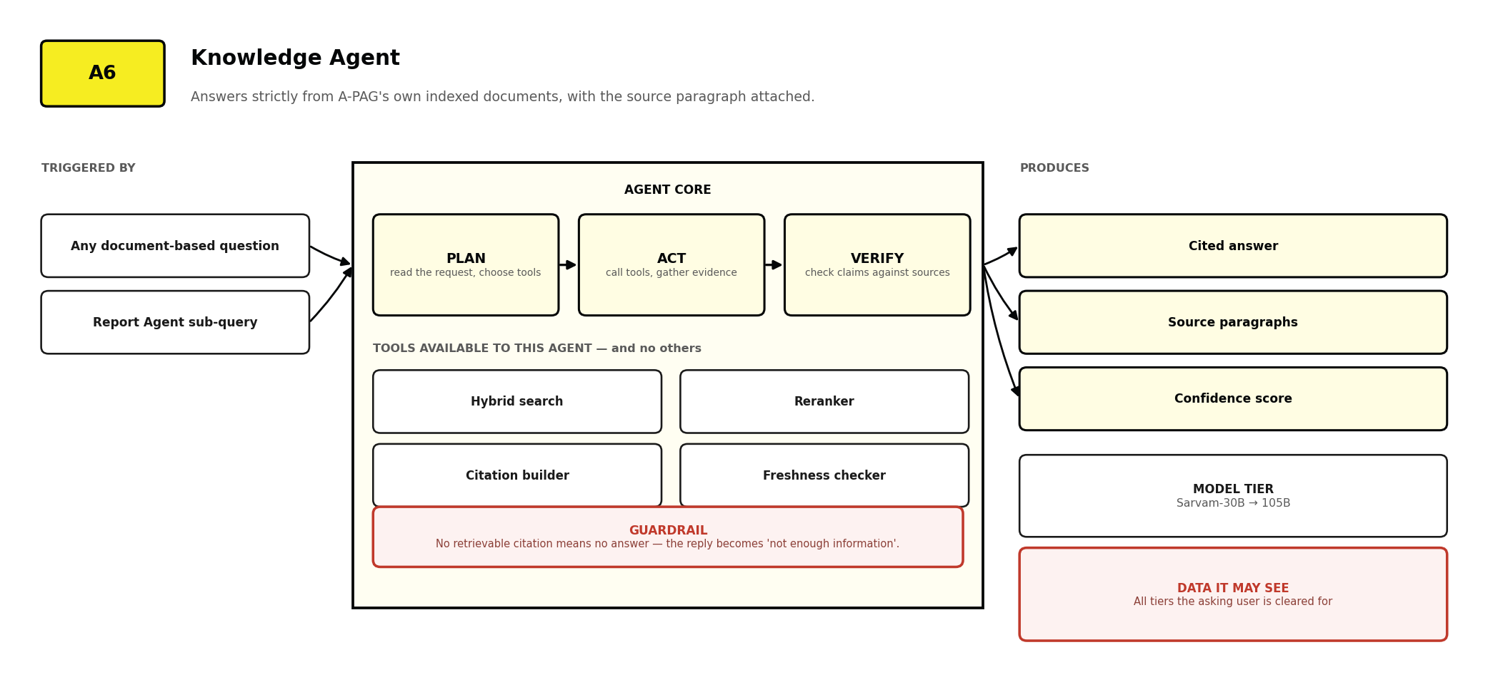
Figure 21 Knowledge Agent — triggers, tools, model tier, data access and guardrail.
- It cannot answer from general world knowledge. If the answer is not in a retrieved passage, the honest output is that the platform does not know.
- It escalates to the larger model only when retrieved context exceeds a length threshold or synthesis spans more than four documents.
- Freshness is surfaced, not hidden: an answer resting on a document older than two years carries a visible flag.

A7 · Answer Critic Agent
A second pair of eyes on every draft narrative answer. It extracts each factual claim, matches it back to a retrieved passage, and reports anything it cannot ground.
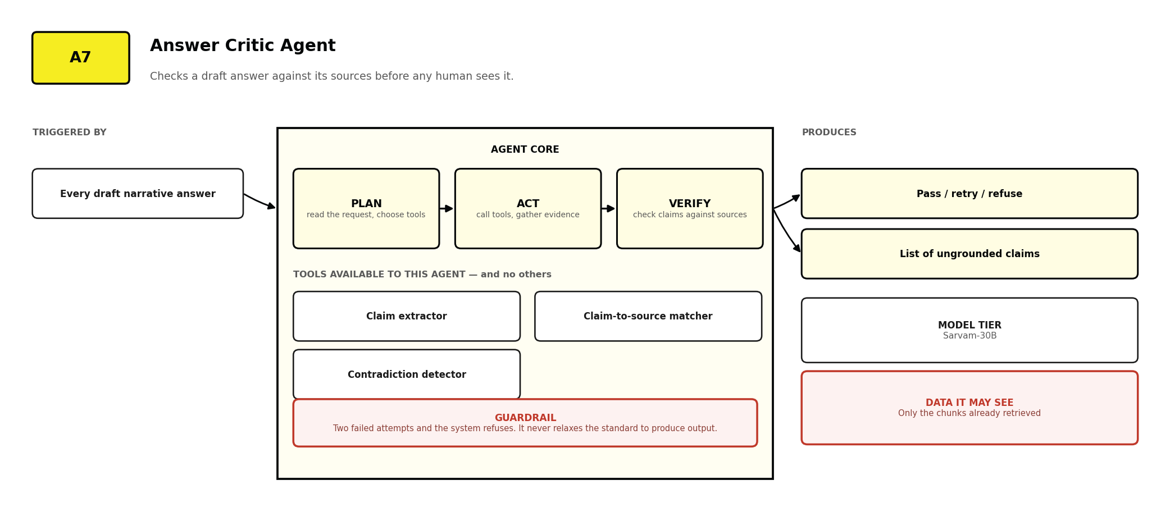
Figure 22 Answer Critic Agent — triggers, tools, model tier, data access and guardrail.
- It sees only passages already retrieved, so it cannot invent support the answering agent did not actually use.
- Three outcomes only: pass, retry, refuse. There is no fourth in which an ungrounded answer is released with a caveat.
- Its pass rate appears in the quarterly transparency report. A rising rejection rate signals a retrieval problem, not a model problem.

A8 · Report Agent
Turns gathered evidence into a structured first draft against a template, leaving the analyst to review and decide rather than assemble and format.
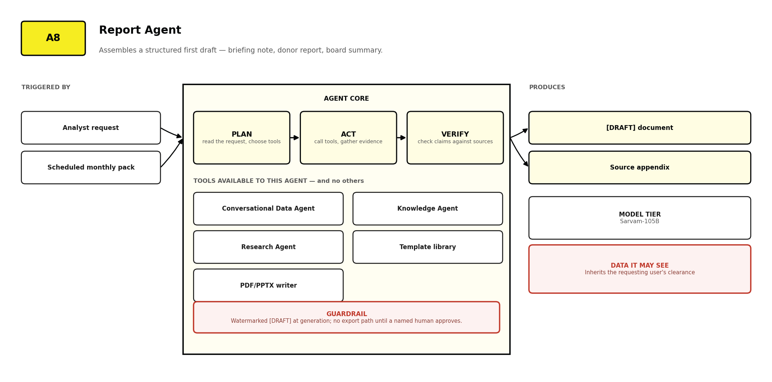
Figure 23 Report Agent — triggers, tools, model tier, data access and guardrail.
- It commissions other agents rather than retrieving directly, so every figure inherits the provenance of the agent that produced it.
- Output is watermarked [DRAFT] at generation, not at export, and has no export path until a named human approves.
- It never invents a number. An unsourceable figure appears as an explicit gap, which is more useful than a plausible fabrication.

A9 · Research Agent
Queries the open academic record and returns findings organised with citations, rather than a list of links to follow up manually.
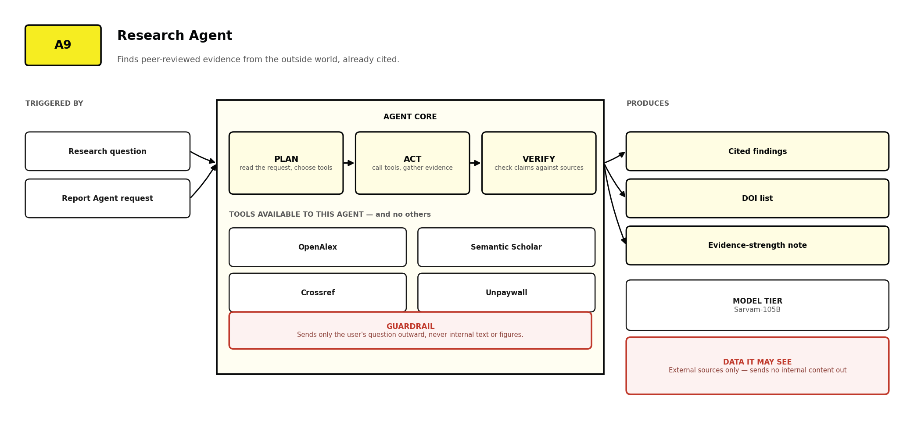
Figure 24 Research Agent — triggers, tools, model tier, data access and guardrail.
- It sends the user's question outward and nothing else. No internal document text or figure is ever included in an external query.
- It prefers open-access full text so a claim can be verified rather than merely cited from an abstract.
- It reports evidence strength — sample size, study design, venue — because a preprint and a meta-analysis should not carry equal weight in a government submission.

A10 · Compliance & Obligation Agent
Reads regulations and signed agreements, extracts the obligations they create, assigns each an owner and deadline, and escalates before the deadline rather than after.
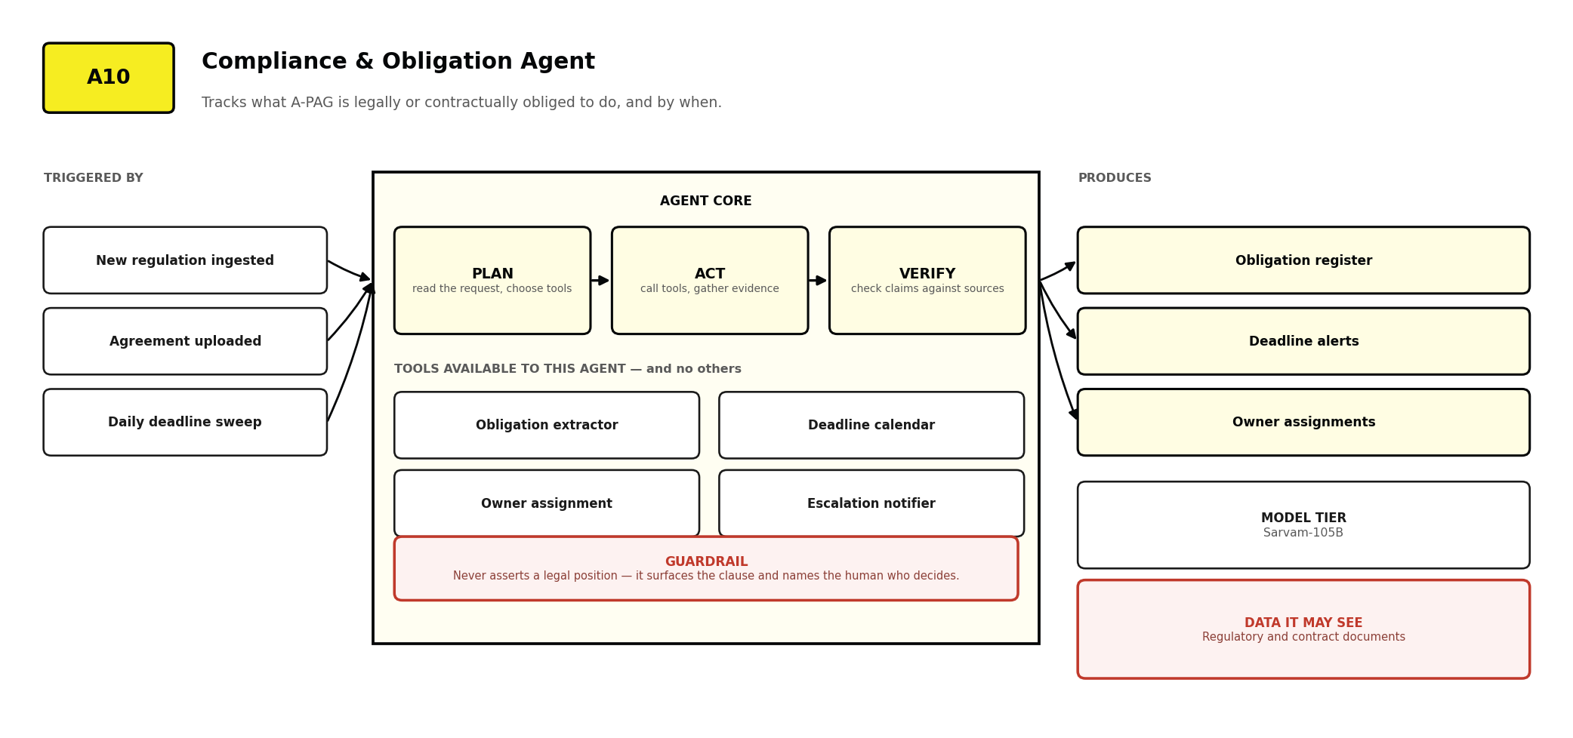
Figure 25 Compliance & Obligation Agent — triggers, tools, model tier, data access and guardrail.
- It never asserts a legal position. It surfaces the clause, states the deadline, and names the human who must decide.
- It reads grant agreements as well as regulations, so donor and statutory obligations sit in one register rather than two systems.
- An obligation with no assigned owner is itself an escalation. Unowned obligations are the ones that get missed.

A11 · Knowledge Transfer Agent
Captures what a departing staff member knows while they are still present, rather than discovering the gap three months later.
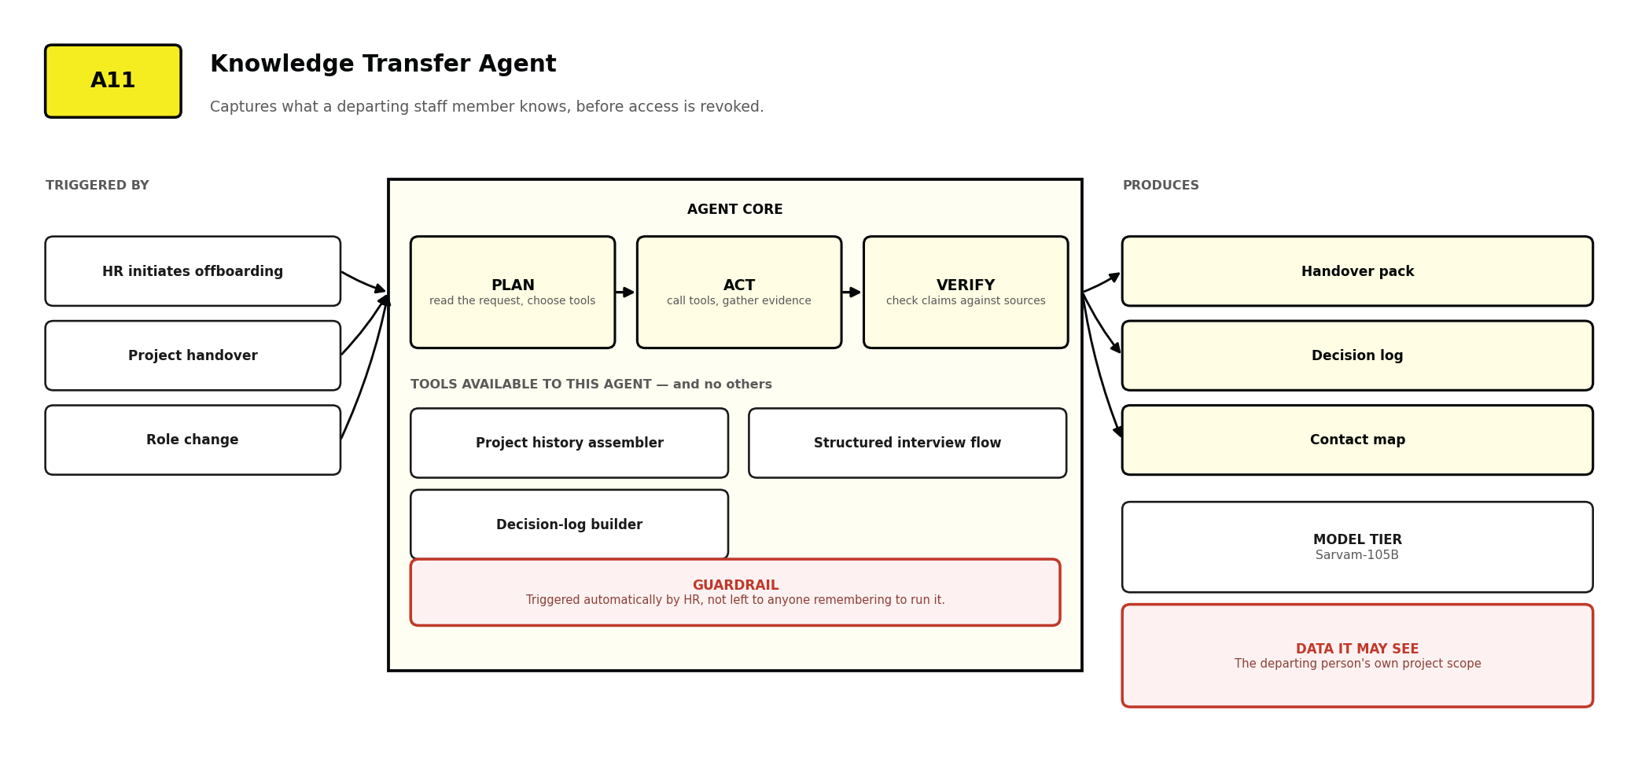
Figure 26 Knowledge Transfer Agent — triggers, tools, model tier, data access and guardrail.
- Triggered automatically by HR when offboarding begins — not left to anyone remembering, which is why most handover processes fail.
- It assembles the factual history automatically, then interviews the person only about reasoning that is not written down anywhere.
- The output is a handover pack a successor can query directly, not a document that sits unread in a folder.

A12 · External Monitoring Agent
Watches every source that matters to A-PAG continuously, so no analyst begins the morning checking six government portals by hand.
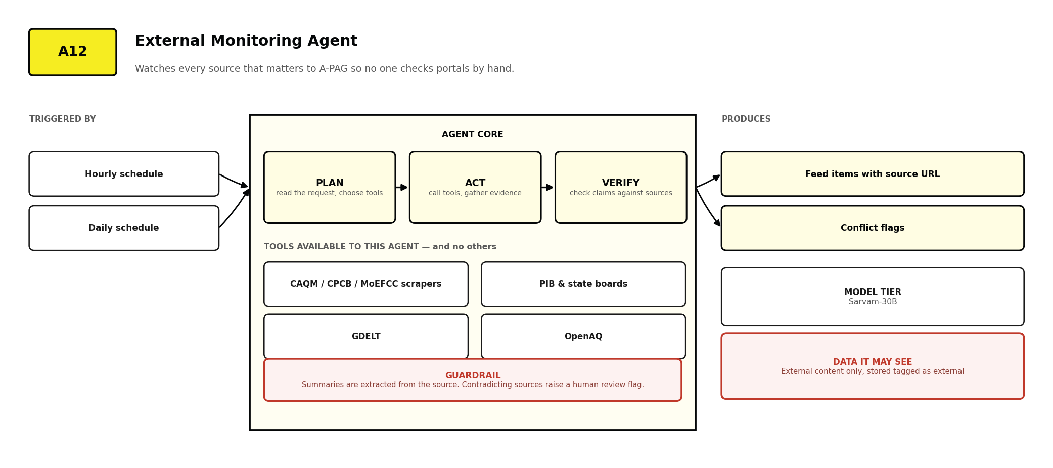
Figure 27 External Monitoring Agent — triggers, tools, model tier, data access and guardrail.
- Summaries are extracted from the source, never composed from general knowledge, and carry the original URL and timestamp.
- Two sources contradicting each other raises a human review flag. The system never silently picks a winner.
- Scrapers fail. A circuit breaker opens after repeated failures and the feed shows a stale-source warning — rather than going quietly empty for a fortnight.

A13 · Internal Feed Agent
The cross-departmental notice board, built so updates become permanent organisational records rather than messages that scroll away.
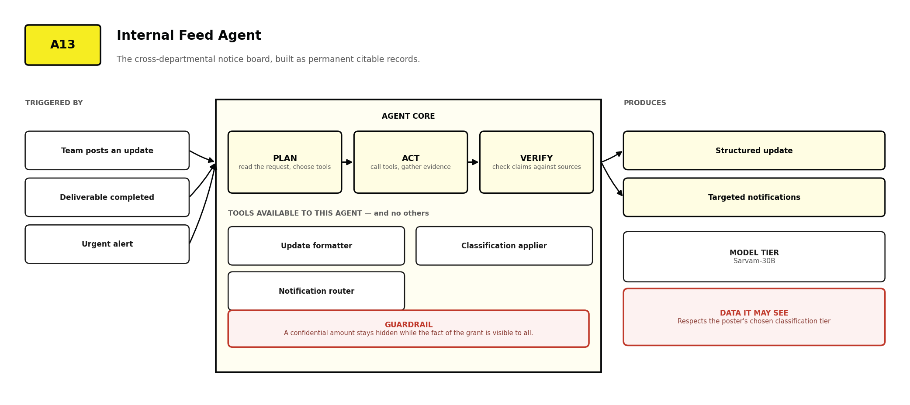
Figure 28 Internal Feed Agent — triggers, tools, model tier, data access and guardrail.
- Every update is stored as a document, so it can be cited by the Knowledge Agent and produced for an auditor. A WhatsApp message cannot.
- Classification applies to updates, so the fact of a grant can be visible organisation-wide while the amount stays with Fundraising and the CEO Office.
- Urgent alerts route immediately to every department with an owner and deadline attached, and remain in the record afterwards.

A14 · Fundraising Intelligence Agent
Keeps proposal evidence current and matches A-PAG's demonstrated work to what a specific donor actually funds.
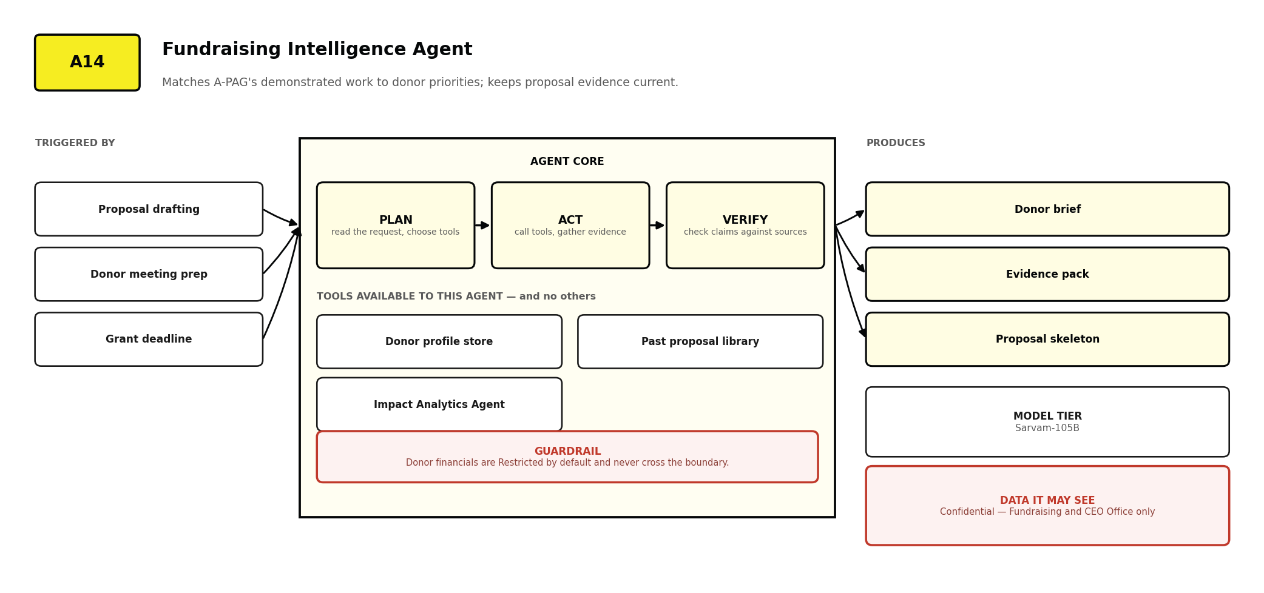
Figure 29 Fundraising Intelligence Agent — triggers, tools, model tier, data access and guardrail.
- Donor financial detail is Restricted by default, so this agent runs on the in-house model whenever such material is in context.
- It reuses the evidence base rather than the prose of past proposals, so repeated claims stay consistent and stay sourced.
- Scoped to Fundraising and the CEO Office. No other department can invoke it, and its outputs do not appear in general search.

A15 · HR Policy Agent
Answers routine staff administration questions from the handbook, so HR is not asked the same six questions every month.
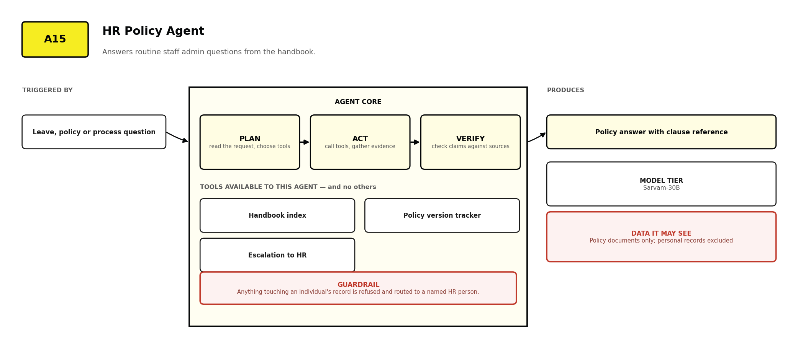
Figure 30 HR Policy Agent — triggers, tools, model tier, data access and guardrail.
- It reads policy documents only. Anything touching an individual's record is refused and routed to a named HR person.
- It cites the clause and policy version, because an answer about leave entitlement is only useful with the rule attached.
- It is excluded from the Publishing Agent's source set, so internal HR policy cannot leak into external content.

A16 · Publishing Agent
Drafts outward-facing content — blogs, newsletters, press notes — and is structurally incapable of publishing any of it.
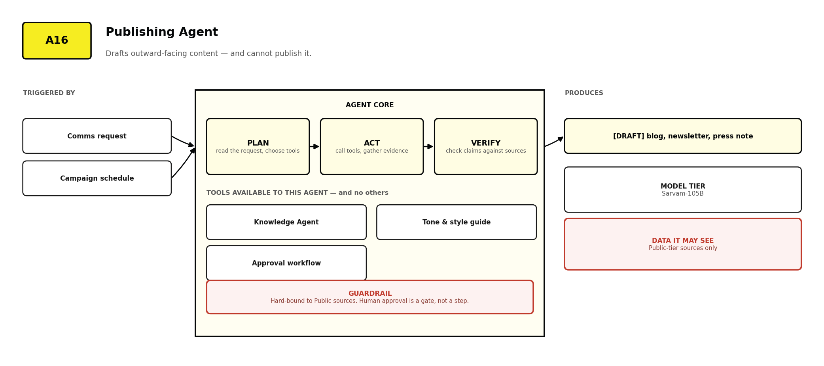
Figure 31 Publishing Agent — triggers, tools, model tier, data access and guardrail.
- Hard-bound to Public-tier sources. Internal, Confidential and Restricted material is not merely filtered out; it is not in its retrieval scope.
- Human approval is a gate, not a step. The draft has no export, send or publish path until a named approver acts.
- It does not attribute quotations to named individuals unless the quotation exists verbatim in an approved source.

A17 · Field Capture Agent
Turns a voice note from a site visit into a structured, searchable, geotagged record — the highest-value and most-neglected knowledge source in a field organisation.
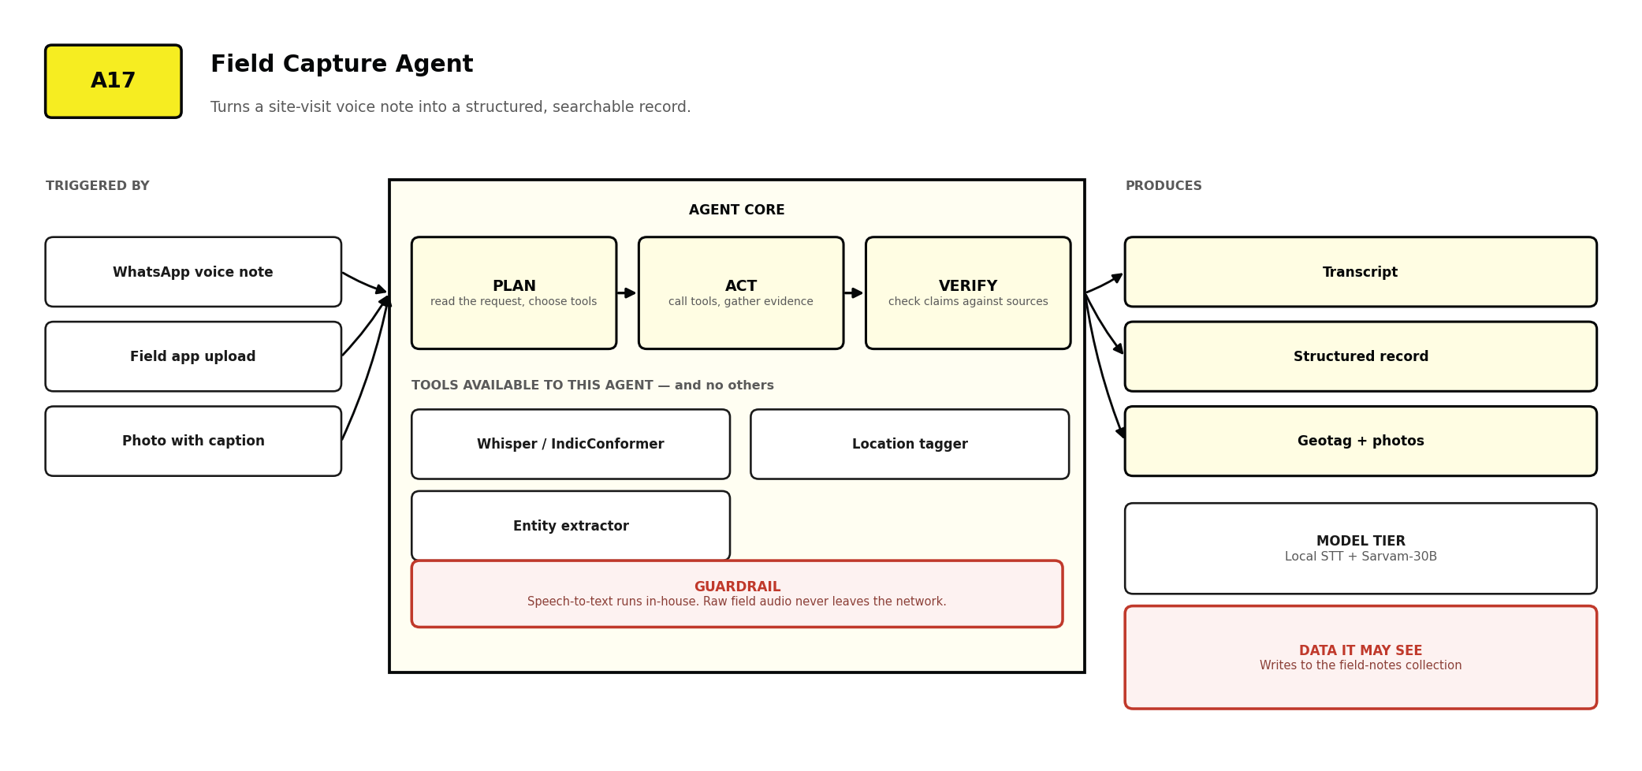
Figure 32 Field Capture Agent — triggers, tools, model tier, data access and guardrail.
- Speech-to-text runs entirely on A-PAG's hardware. Raw field audio is unclassified by definition and never leaves the network.
- It extracts location, date, site identifier and observations into structured fields, so a field note becomes queryable data.
- It works over WhatsApp, where field teams already are. Asking field staff to adopt a new application is how these projects die.

13 Guardrails and Answer Integrity
WHAT THE SYSTEM REFUSES TO DO
IN PLAIN TERMS
The most important behaviour of this platform is not what it answers — it is what it declines to answer. A system that produces a confident, unsourced, plausible number for a donor report is worse than no system at all, because it transfers the error into a document carrying A-PAG's name.

Guardrail | What it does | On failure
Provenance requirement | Every narrative claim maps to a retrieved passage; every number carries its query and as-of date | The claim is removed; if nothing survives, the answer becomes 'not enough information'
Certified-metric confinement | SQL is generated only against blessed metrics and joins | The question is refused with an offer to define the metric
Query validation | Static inspection before execution — no writes, no unbounded scans, no unblessed joins | Rejected, regenerated once, then refused
Confidence threshold | Retrieval relevance must clear a minimum before generation is attempted | The system asks for a clearer question rather than answering a poor match
Prompt-injection detection | Text inside an ingested document cannot issue instructions to the system | Neutralised, the document is quarantined, and the IT team is notified
Tier ceiling | An agent cannot receive a passage or column above its permitted tier | Excluded before the agent is invoked; the exclusion is logged
Freshness flag | Sources older than two years, and stale source tables, are marked in the answer | Delivered with a visible warning, never silently
Supersede exclusion | A superseded document is never cited alongside its replacement | Dropped before generation
Spend ceiling | Per-user and per-department daily token limits | Queued to the next day; the user and the department head are both told

13.1 Prompt injection deserves particular attention
A platform ingesting documents from government portals, email attachments and WhatsApp exports is ingesting text written by people outside A-PAG. Some of it can be crafted to manipulate a model that later reads it — an instruction hidden in a PDF telling the system to ignore its restrictions.
- Retrieved content is passed to models as clearly delimited data, never as instructions, with a system-level rule that anything inside those delimiters is information to reason about rather than commands to follow.
- NeMo Guardrails screens retrieved content for instruction-like patterns before it reaches a model.
- An agent's tool list is fixed at registration. Even a successful injection cannot grant a tool the agent was not configured with, because binding happens outside the model's reach.
- A document triggering injection detection is quarantined for human review before indexing — not merely stripped and passed through.

14 Data Architecture
FIVE STORES, EACH WITH ONE JOB
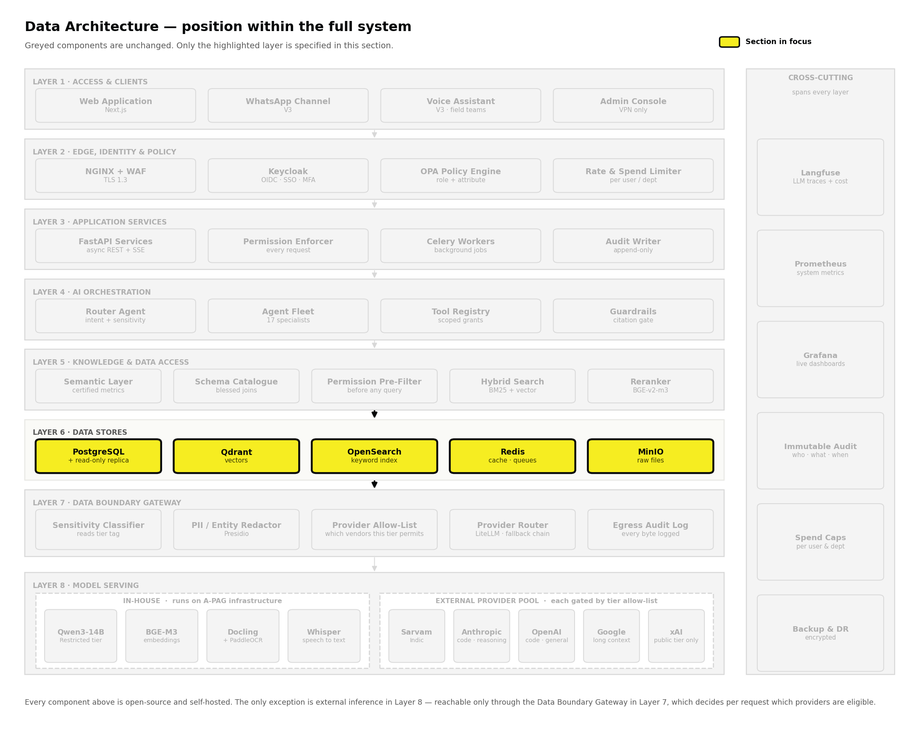
Figure 33 The data layer. All five stores run on A-PAG's own infrastructure.

Store | What it holds | Why this one
PostgreSQL | Users, roles, departments, operational records, metrics, document metadata, obligations, audit log | Row-level security is native to the database, so permission survives a query issued outside the application. A read-only replica serves the Conversational Data Agent.
Qdrant | Document passages as embeddings, pre-tagged with tier and department | Metadata filters apply during search rather than after — the property that makes pre-filtering possible. Apache-2.0 and self-hostable.
OpenSearch | Full text of every passage for exact-term matching | Apache-2.0 fork of Elasticsearch with no licensing restriction on self-hosted use.
Valkey | Semantic cache, job queue, session state, rate-limit counters | BSD-licensed fork of Redis, adopted because Redis moved to a source-available licence in 2024 that would breach the open-source mandate.
MinIO | Original uploaded files, generated reports, field photographs, audio | S3-compatible, so any future migration is trivial. Files never leave A-PAG's infrastructure.

14.1 External and internal data are architecturally separate
Content from the outside world and A-PAG's own records are never blended — not in the same table, not in the same retrieval result, not on the same screen. The separation is structural rather than conventional, because a convention survives exactly as long as the person who remembers it.

External signal | Internal record
Government portals, WHO, research databases, news | A-PAG's own KPIs, beneficiaries, budgets, field readings
Ingested on a schedule by the External Monitoring Agent | Queried live by the Conversational Data and Impact Agents
Stored in Qdrant tagged source_type: external | Stored in PostgreSQL, A-PAG's own database
Cited as 'according to CPCB' | Cited as 'A-PAG's own recorded data, as of <date>'

14.2 Engineering choices behind performance

Problem | Structure used | Where
Nearest-neighbour search across millions of passages | Hierarchical navigable small world graph | Qdrant vector index
Keeping the best K results without sorting everything | Min-heap | Reranking stage
Multi-step agent reasoning that must terminate | Directed acyclic graph | LangGraph orchestration
Fast permission and role resolution per request | Hash map plus department graph | OPA policy evaluation
Document lineage: draft, final, superseded | Tree with parent pointers | Document versioning
Resolving business vocabulary to columns | Trie plus alias map | Semantic layer lookup

14.3 Backup, retention and recovery
- PostgreSQL: continuous archiving with point-in-time recovery, nightly full backup, encrypted, retained twelve months.
- Qdrant and OpenSearch: nightly snapshots. Both are rebuildable from MinIO and PostgreSQL, so they are recoverable rather than irreplaceable.
- MinIO: versioned buckets with object-lock on the audit and classification stores, so those records cannot be altered even by an administrator.
- Recovery is rehearsed quarterly against a restored copy. A backup that has never been restored is a hypothesis, not a backup.

15 Observability, Audit and Cost Control
LIVE FROM DAY ONE, NOT ADDED IN VERSION TWO
From the first day the platform is live, A-PAG must be able to answer three questions at any moment: what is it doing, what is it costing, and can we prove what happened. All the tools that answer them are open-source and run on A-PAG's own servers.
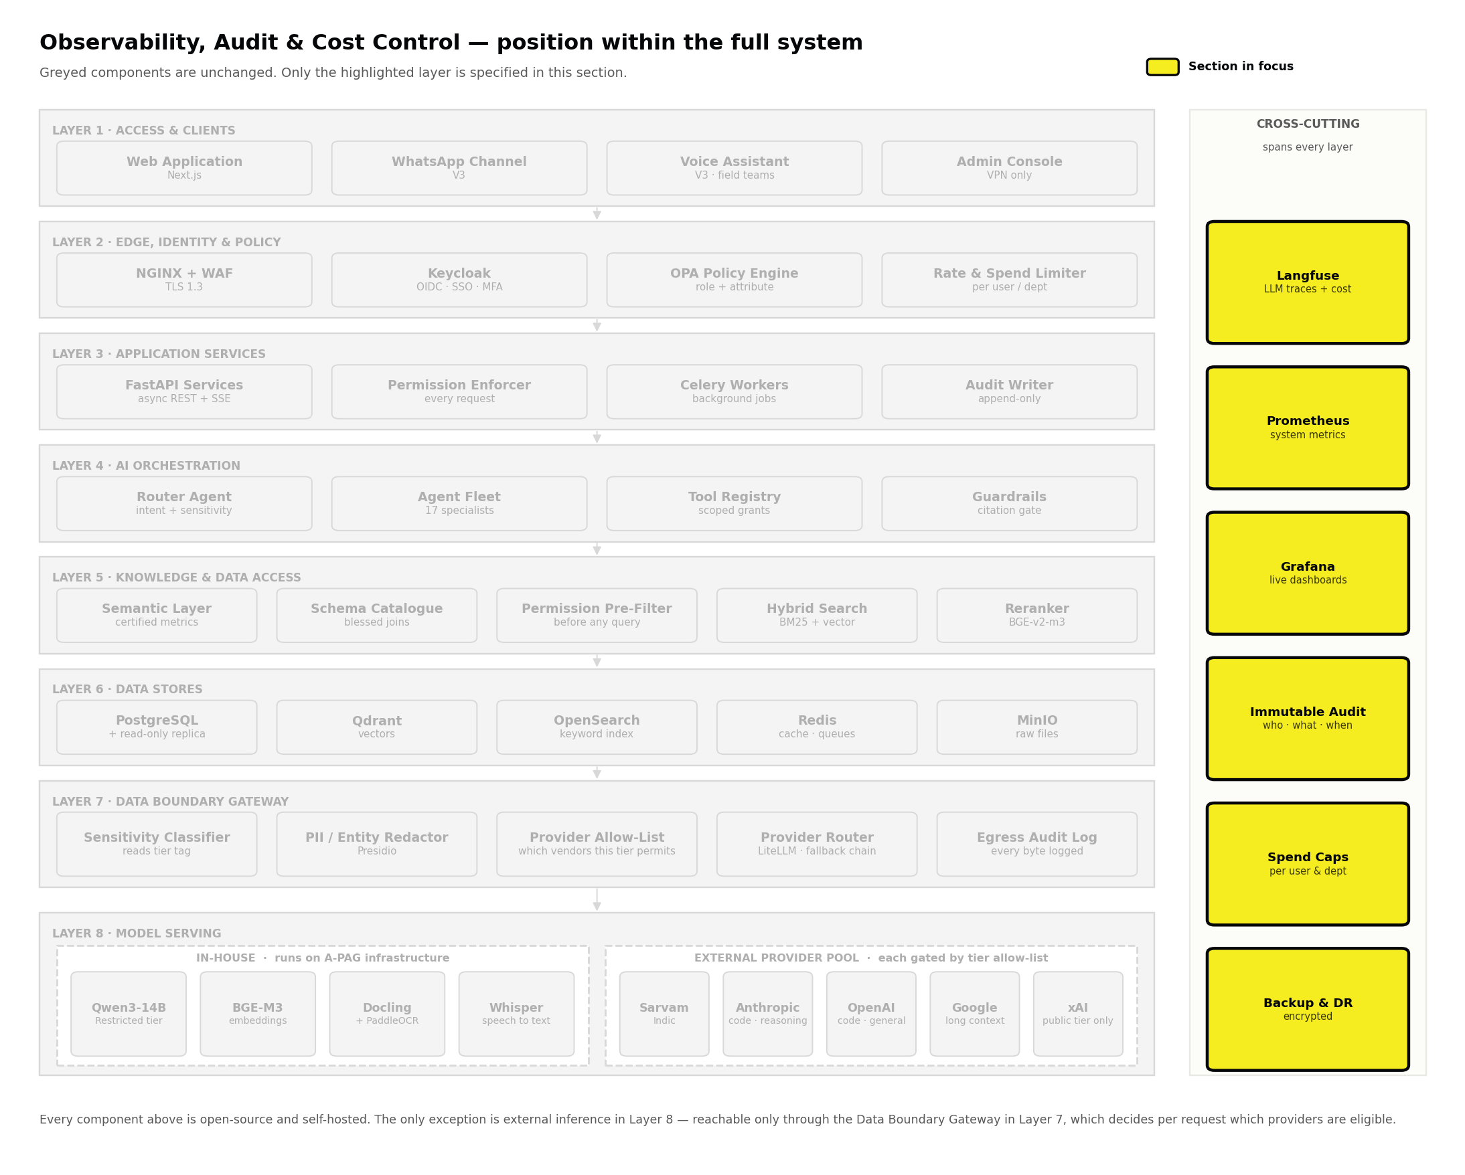
Figure 34 Observability spans every layer rather than sitting inside one.

Tool | What it captures | Who looks at it
Langfuse | Every model call: agent, provider, model, prompt, response, tokens, latency, cost, feedback, full trace | Technology Lead daily; engineers on every defect
LiteLLM router logs | Routing decisions: tier, task class, eligible pool, chosen provider, fallbacks triggered, per-key spend | Technology Lead weekly; drives the quarterly register review
Prometheus | CPU, memory, disk, queue depth, request latency, error rates, ingestion backlog | IT team; alerts on threshold breach
Grafana | Dashboards over both, including per-department cost and query-rejection rates | Technology Lead, CEO Office, department heads
Audit ledger | Every document access, classification change, approval, administrative action — append-only | Auditors on request; reviewed quarterly
Egress log | Every byte that crossed the sovereignty boundary, with tier and destination | Technology Lead monthly; auditors on request

15.1 Cost visibility is distributed, not centralised
The people who can change a usage pattern are the people who need to see the number. Concentrating cost data in the IT team produces a monthly complaint rather than a behaviour change. Every department head sees their own consumption daily; caps are enforced at Layer 2 so a runaway script cannot consume a month's budget overnight; and the ten most expensive queries each week are reviewed — most turn out to be routing errors, a task sent to a frontier model that a small one would have answered, and are cheap to fix once visible.

15.2 What an auditor can be given
For any answer the platform has produced: the question, the asker, the exact document versions or the executed query, the data as-of date, which model answered, whether anything crossed the boundary and in what redacted form, the guardrail decisions, and the approver if it was published. Generated as a pack rather than assembled by hand — the difference between an audit that takes an hour and one that takes a fortnight.

16 Deployment and Engineering Practices
BUILT TO BE MAINTAINED BY SOMEONE WHO DID NOT BUILD IT
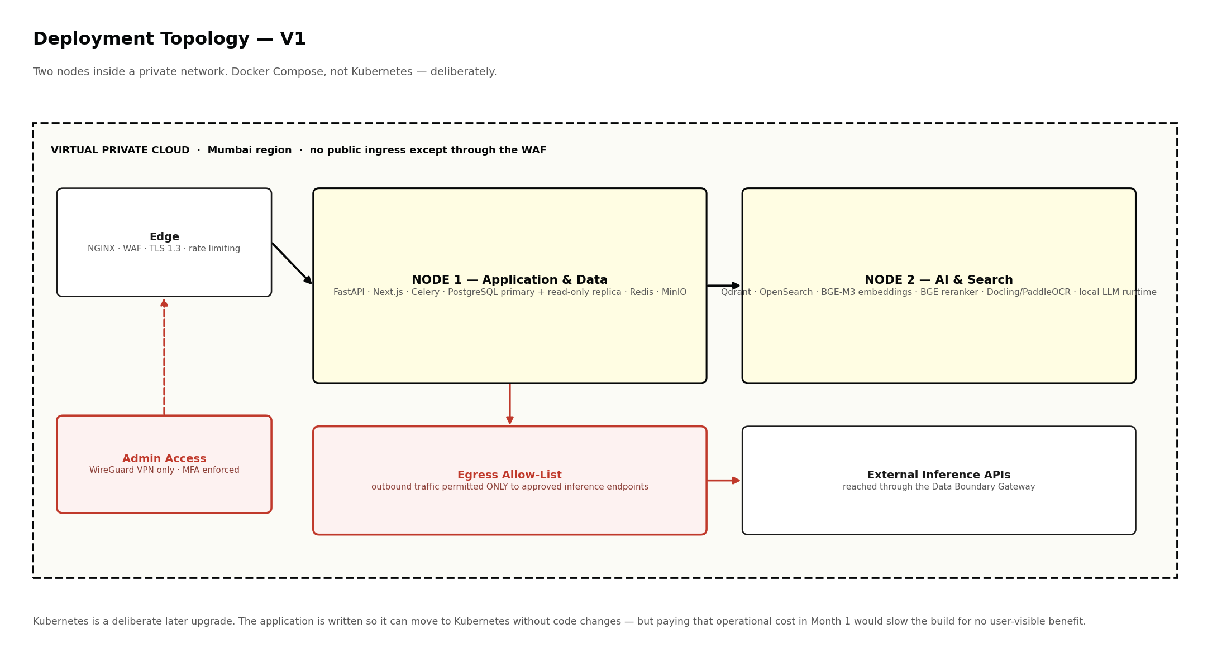
Figure 35 V1 topology: two nodes in a private network, administrative access by VPN only.

16.1 Five patterns that keep the system replaceable

Pattern | What it guarantees | Concretely, here
Hexagonal architecture | Core logic is isolated from any interface or provider | Replacing the inference provider requires no change to retrieval, semantic layer or agent logic
Strategy pattern | Providers are swappable, not hard-coded | All calls go through the LiteLLM router; adding or reordering a provider is a configuration change
Event-driven ingestion | Document processing is a chain of events, not one long function | Uploaded → parse → embed → notify; any stage can be retried alone
Circuit breaker and retry | An external failure degrades one feature, not the platform | A portal scraper fails → circuit opens → the feed shows a stale-source warning
Agent factory and registry | New agents are added without modifying the router | The router asks the registry for the agent matching a classified intent

16.2 Why Docker Compose and not Kubernetes
V1 runs on Docker Compose across two nodes, and the application is written so Kubernetes can be adopted later without changing application code. Adopting it inside a twenty-week build window would add cluster management, networking and upgrade cycles to a team already building the platform, for no benefit any user would notice. The right moment is when service count and deployment frequency make the manual overhead larger than the operational cost — for fifty people, unlikely inside the first year.

16.3 Environments and release
- Three environments: development, staging with a de-identified copy of real data, and production. No engineer holds standing write access to production data.
- Schema changes are versioned migrations, applied forward only, tested against a restored production backup before release.
- Every release is preceded by an evaluation run against a fixed question set with known correct answers — including a set of numeric questions with verified figures. A regression in provenance accuracy or a numeric mismatch blocks release.
- Secrets live in a managed secret store, never in configuration files or the repository. Rotation is quarterly and scripted.

PART C · DELIVERY

17 Delivery Plan and Dependencies
17 AUGUST 2026 → 29 JANUARY 2027 · TWENTY-FOUR WEEKS · HANDOVER INCLUDED
THE SHAPE OF THIS PLAN
The end date is fixed: the platform is handed over on 29 January 2027. That gives twenty-four working weeks from 17 August 2026, of which the last four are handover rather than build.
Twenty weeks of build will not deliver everything in this document. Attempting it would produce a plan that looks complete in August and fails in December. So the scope is the variable and the date is not: Pillars 1 and 2 land properly, with a real handover. Pillars 3 and 4 are specified in full and scheduled after handover.

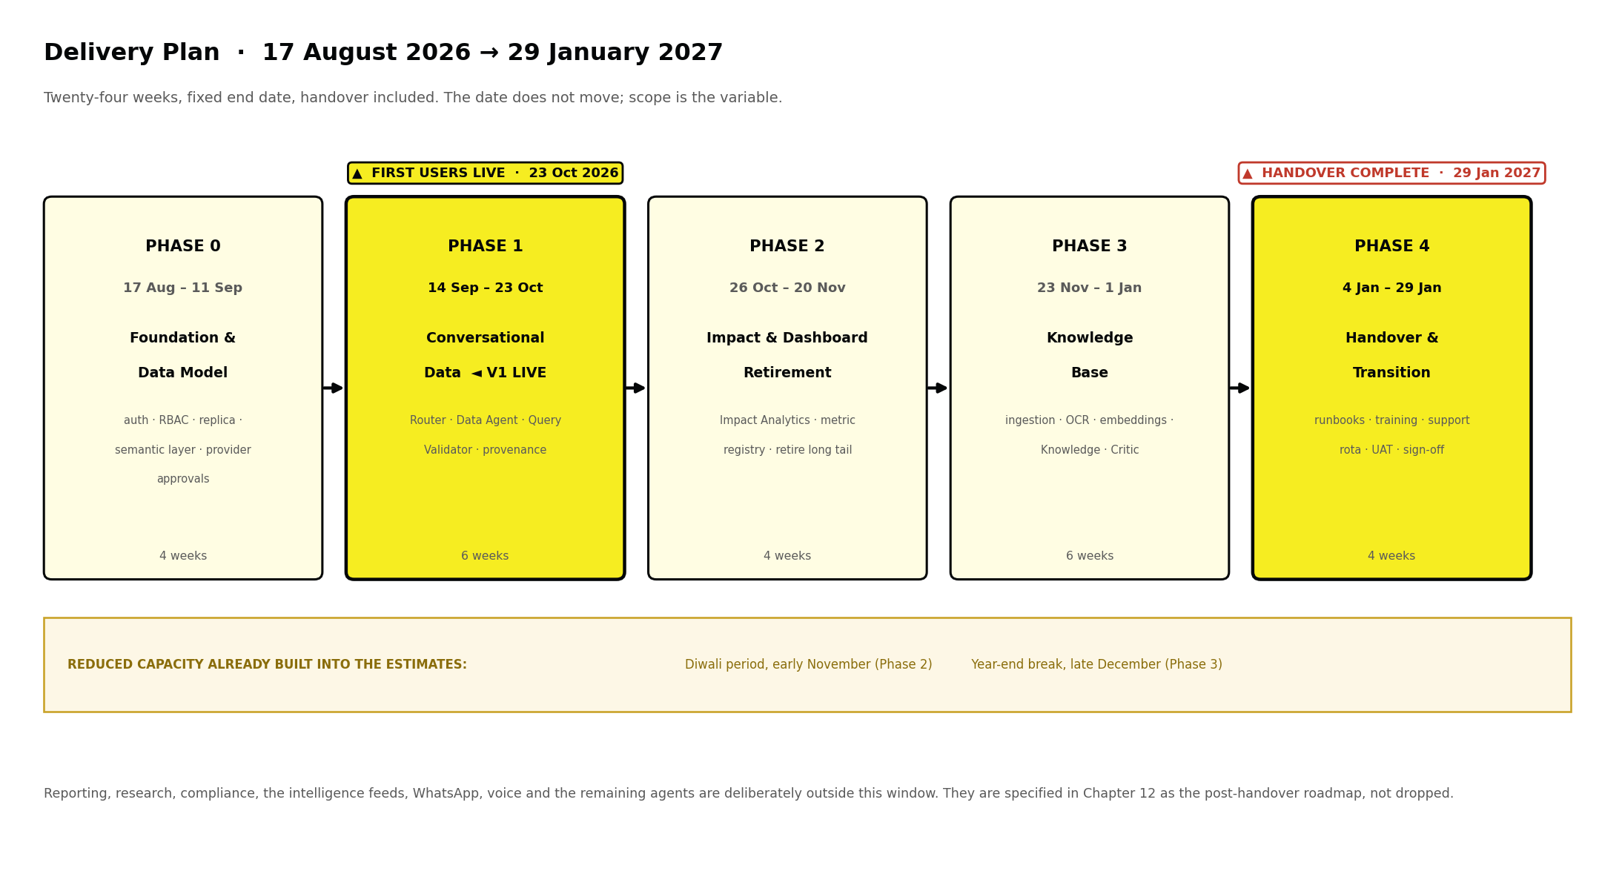
Figure 36 The delivery window. First users are live on 23 October 2026; handover completes 29 January 2027.

Phase | Dates | What gets built | Hard dependency
Phase 0  4 weeks | 17 Aug –  11 Sep 2026 | Authentication, roles and policy engine; PostgreSQL primary and read-only replica; the semantic layer — certified metrics, blessed joins, column classification; Valkey; MinIO; Langfuse and Prometheus; network and VPN; provider approvals obtained | None. This is the foundation, and the semantic layer is its hardest part.
Phase 1  6 weeks | 14 Sep –  23 Oct 2026 | Router, Conversational Data Agent, Query Validator, provenance display, row-level security verification on the replica. First users go live. | Semantic layer signed off by department heads before generation is tested
Phase 2  4 weeks | 26 Oct –  20 Nov 2026 | Impact Analytics Agent, metric registry, dashboard instrumentation and retirement of the long tail | Conversational path stable and reconciling against existing dashboards
Phase 3  6 weeks | 23 Nov 2026 –  1 Jan 2027 | Document pipeline end to end, Knowledge Agent, Answer Critic, citation viewer, department workspaces | Document migration sprint, which runs in parallel from Phase 2
Phase 4  4 weeks | 4 Jan –  29 Jan 2027 | Runbooks and architecture decision records, operator and administrator training, support rota, final user acceptance testing, sign-off and handover | Everything above stable in production

17.1 What handover actually means
Handover is a four-week phase with its own deliverables, not a meeting on the last Friday. A platform that only its builders can operate has not been handed over, whatever the contract says.

Deliverable | Acceptance test
Runbooks for every routine operation — ingestion, reclassification, provider change, metric change, restore | A named operator performs each one unaided, watched but not helped
Architecture decision records covering every choice in this document | A reviewer can answer 'why was this chosen' without asking the build team
Administrator training on access, classification, provider allow-list and spend caps | The administrator completes a live change in each area
Department-head training on certified metrics and the correction loop | Each department amends one metric definition end to end
Support rota, escalation path and on-call arrangement agreed | One incident rehearsed against the escalation path
Two weeks of independent operation before sign-off | The receiving team runs the platform in production with the build team on standby only

17.2 There is no float, so this is what gets cut first
Twenty build weeks against this scope leaves no contingency. That is a deliberate, stated position rather than an oversight, and it means slippage must be absorbed by scope rather than by the date or by the handover. If a phase runs late, cut in this order and no other.
- Dashboard retirement (Phase 2) moves after handover. The conversational path still works; the old dashboards simply stay alive longer, which costs maintenance rather than capability.
- The knowledge base reduces to ingestion, hybrid search and the citation viewer, with narrative answering deferred. Users can still find the right paragraph; the system just does not compose prose around it.
- Nothing else. The foundation, the conversational data path, the guardrails and the handover phase are not available for compression.

WHAT MUST NOT BE CUT, UNDER ANY PRESSURE
The semantic layer sign-off, the Query Validator, provenance display, the classification model and the four handover weeks. Each of these is the thing that makes the rest safe or transferable. A platform delivered on time that produces unverifiable numbers, or that nobody at A-PAG can operate in February, has not been delivered.

17.3 The hardest single problem
It is not the artificial intelligence, and it is not the schedule. It is agreeing, once and in writing, what A-PAG's numbers mean.
Certified metrics require department heads to settle definitions that have historically differed between teams — what counts as a beneficiary reached, when a deliverable is complete, which date a grant is recognised on. This is organisational work, it cannot be automated, and all four weeks of Phase 0 depend on it. If those definitions are not owned by named people in the first week of September, the 29 January date is already at risk, and every week of delay there is a week taken from Phase 3 at the other end.
Capacity has been reduced in the estimates for the Diwali period in early November and the year-end break in late December. Those are the two points where an optimistic plan silently loses a fortnight.

18 What This Costs
STATED HONESTLY, INCLUDING THE PARTS MORE EXPENSIVE THAN THE ALTERNATIVE

18.1 Two configurations
The difference is one decision: whether the platform can generate AI answers over Restricted content in V1, which requires a GPU node running an in-house model.

Component | Configuration A | Configuration B
Node 1 — application and data (8 vCPU, 32 GB, reserved, Mumbai) | ₹12,000 – 16,000 | ₹12,000 – 16,000
Node 2 — AI and search (16 vCPU, 64 GB) | ₹18,000 – 24,000 | ₹18,000 – 24,000
Node 3 — GPU for in-house inference on Restricted content (L4 24 GB class) | — | ₹22,000 – 35,000
Object storage, snapshots and offsite backup | ₹3,000 – 6,000 | ₹3,000 – 6,000
External inference — blended across providers after routing | ₹6,000 – 14,000 | ₹6,000 – 14,000
Observability — Langfuse, Prometheus, Grafana, all self-hosted | ₹0 – 2,000 | ₹0 – 2,000
Network, firewall, VPN, domain | ₹2,000 – 4,000 | ₹2,000 – 4,000
Research and benchmarking tools (never on production data) | ₹2,000 | ₹2,000
Monthly total | ₹43,000 – 68,000 | ₹65,000 – 103,000

18.2 The recommendation
The external inference figure falls against a single-provider estimate, because routing sends the bulk of traffic — classification, tagging and short answers — to small models rather than to a frontier model by default. Begin with Configuration A. Phase 1 does not need a GPU at all — the conversational data path runs on external inference for non-restricted columns and simply withholds narration where a Restricted column is present, returning the figure without commentary. Move to Configuration B when the volume of Restricted queries justifies it, which will be visible in Langfuse rather than a matter of opinion. Adding the node is a provisioning task, not an engineering project.

18.3 The comparison leadership will ask for

 | Today | Configuration A
Monthly cost | ₹23,000 | ₹43,000 – 68,000
Staff covered | 23 of 50 | 50 of 50
Cost per person per month | ₹1,000 | ₹860 – 1,360
Can query A-PAG's own database | No | Yes, under each user's own permissions
Sensitive data leaving A-PAG's control | Yes, by design | No — Restricted never leaves; Confidential only tokenised
Organisational memory retained | None | Permanent and versioned
Dependence on a single AI vendor | Total | None — several approved providers, swappable by configuration
Asset owned at year end | None | The semantic layer, the knowledge base, the corrections, the evaluation history

SAY THIS IN THE BOARD MEETING
Per person the cost is roughly flat; in absolute rupees it is higher. What A-PAG buys for the difference is the ability to ask its own database a question in English, sovereignty over its own material, coverage of the whole staff rather than half, an auditable record, and an asset that appreciates. If the board is asked to approve this as a saving, the wrong case is being made and it will not survive Month 6.

18.4 What is deliberately not being bought
- Model fine-tuning. Retrieval and semantic-layer quality are the constraints in year one, not model weights.
- Kubernetes. Deferred until service count justifies the operational cost.
- A separate data warehouse. The read-only replica plus the semantic layer is sufficient at A-PAG's data volume; a warehouse is a solution to a scale problem A-PAG does not have.
- Multi-region redundancy. A single region with tested backups is the correct posture at this size.
- Dedicated or reserved capacity from a single frontier vendor. It costs several times the routed spend above and re-creates exactly the dependence the provider pool exists to avoid.

19 Risks
NAMED, OWNED, MITIGATED

Risk | Mitigation | Owner
A wrong number reaches a donor report or government submission | Generation confined to certified metrics; Query Validator rejects before execution; query, row count and as-of date always displayed | Technology Lead
Metric definitions are never agreed, stalling Phase 0 | Named owner per department from day one; disputes escalate to CEO Office within five working days | CEO Office
Dashboards are retired before the replacement is trusted | Retirement only in Phase 2, only after reconciliation, long tail first, five canonical boards retained | Process Excellence
A confident but unsourced narrative answer | Mandatory citation, Answer Critic, confidence threshold, human sign-off before anything external | Technology Lead
Sensitive material leaves A-PAG's control | Restricted has no egress code path; Confidential is tokenised; every crossing logged and reviewed monthly | Technology Lead
Documents or columns classified incorrectly | Model proposes, human confirms; downgrades need two people; quarterly review of unreviewed items | Department heads
Cost grows unnoticed | Model routing, per-user and per-department caps, semantic caching, daily cost visibility per department | Technology Lead
Users stop trusting the system after one bad answer | Provenance visible from day one, one-click correction flow, visible resolution of corrections raised | Process Excellence
Dependence on a single inference provider | Several approved providers behind one router; fallback chains; in-house path live for Restricted; evaluation history held locally | Technology Lead
Provider sprawl — more vendors, more egress paths | The tier allow-list is the only route to any provider; annual re-approval per endpoint; monthly egress review broken down by provider | Technology Lead
A provider quietly changes region, terms or sub-processors | Written commitments with notification obligations; annual re-confirmation; a provider failing re-approval is demoted automatically | Technology Lead
Routing quality decays as models change | Quarterly evaluation harness sets the quality bar; a model falling below its bar is demoted automatically, not when someone notices | Technology Lead
Prompt injection through an ingested document | Retrieved content delimited as data, screened by NeMo Guardrails, tool bindings fixed outside the model's reach | Technology Lead
Key staff member leaves mid-build | Architecture decision records maintained from Phase 0, so knowledge is not held in one head | CEO Office
Metric definitions are not agreed in Phase 0, shifting the whole schedule | Named owner per department from the first week; unresolved definitions escalate to CEO Office within five working days; a metric with no owner is out of V1 scope by default | CEO Office
Scope creep consumes the twenty build weeks | The cut order in Chapter 17.2 is agreed at sign-off, before pressure arrives, so the decision is already made when it is needed | Technology Lead
Handover is compressed to make room for build | The four handover weeks are ring-fenced and cannot be reallocated. Slippage is absorbed by the Chapter 17.2 cut order instead | CEO Office
The receiving team cannot operate the platform after 29 January | Handover acceptance is a two-week period of independent operation before sign-off, not a document transfer | Technology Lead

20 The Correction Loop and Standing Reports
A SYSTEM THAT CANNOT BE CORRECTED IS A SEARCH INDEX, NOT A TRUST SYSTEM
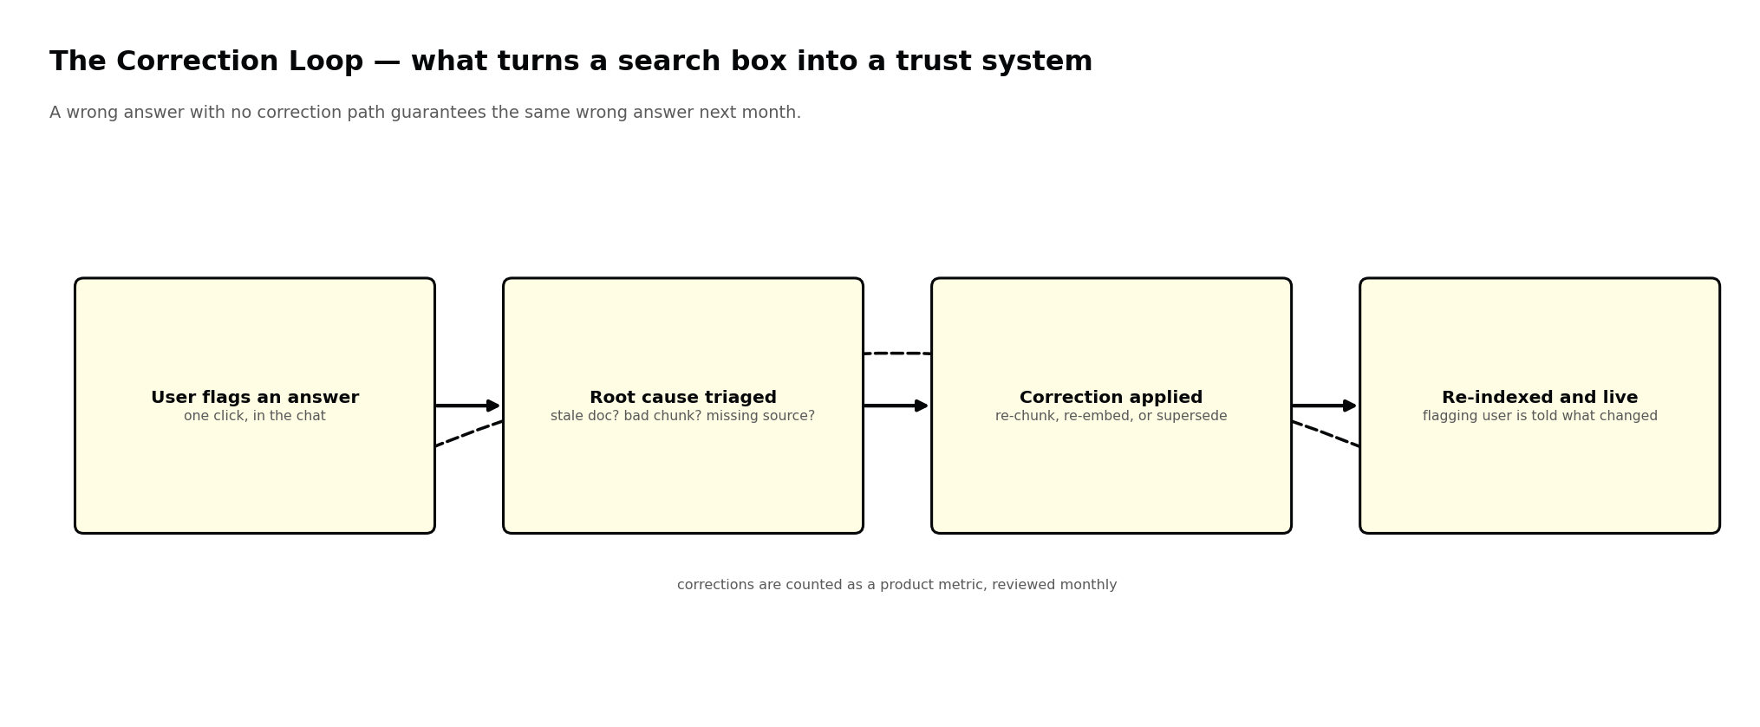
Figure 37 Errors are fixed at their source, not patched at the answer.
Any user can flag an answer as wrong or outdated with one click. The flag is triaged to a root cause — a stale document, a badly placed chunk boundary, a missing source, or a wrong metric definition — and the correction is applied there. Passages are re-chunked or superseded, or the certified metric is amended and re-blessed; the cache is invalidated; and the person who raised the flag is told specifically what changed.
Corrections raised and resolved are product metrics. A rising correction rate on one department's numbers is a signal about the semantic layer, not about the users.

20.1 Standing reports

Report | Goes to | Contains | Cadence
Digest | All staff | New documents ingested, new certified metrics, unresolved query themes, feed highlights | Weekly
Governance report | Technology Lead, IT | Query rejection rate, ingestion backlog, superseded documents, failed parses, stale source tables | Weekly
Classification review | Department heads, CEO Office | Documents and columns unreviewed for twelve months, every downgrade with reason and approvers | Quarterly
Transparency report | Leadership and donors | Refusal rate, provenance accuracy, correction volume and resolution time, cost per query, boundary egress summary | Quarterly
Audit support pack | Auditors, government | Full question-to-provenance trail for any flagged answer, generated on demand | On request

21 Open Decisions and Sign-Off
THESE CANNOT BE RESOLVED BY THE ENGINEERING TEAM ALONE
Each of the following has organisational consequences rather than being a technical preference. A recommendation is offered; the decision belongs to leadership.

# | Decision | Recommendation | If deferred
D1 | Who owns each certified metric definition, and who breaks ties? | One named person per department; CEO Office resolves within five working days | Phase 0 stalls — this is the V1 critical path
D2 | Who receives the handover on 29 January 2027? | A named A-PAG operator plus a named administrator, identified by 30 September 2026 so they can shadow Phases 2 and 3 | Handover becomes a document transfer with nobody accountable
D3 | Which providers are approved, and at which tier? | Sarvam plus one frontier provider at Confidential to start; others at Internal; Grok at Public until its terms are documented | Routing cannot be configured; Phase 1 blocked
D4 | Configuration A or B at launch? | A. Add the GPU node when Langfuse shows the volume justifies it | GPU lead time delays Phase 1 by three to four weeks
D5 | Which dashboards are declared canonical and survive? | Roughly five, named explicitly before Phase 2 begins | Retirement becomes contested case by case and stalls
D6 | Who holds APPROVE for external publication? | Two named individuals per channel, never a role alias | Publishing Agent cannot be scheduled after handover
D7 | Are individual HR records in scope at all? | No. Policy documents only, through V2 | HR Agent scope cannot be fixed for the post-handover roadmap
D8 | Retention period for audit and egress logs | Seven years, aligning with statutory and donor audit expectations | Storage sizing cannot be finalised
D9 | Does the external auditor get time-boxed platform access? | Yes — read-only, scoped, automatically expiring | Audit support becomes a manual export exercise
D10 | Is the platform disclosed to government counterparts? | Yes, proactively, with the sovereignty architecture as the headline | Risk of the question being asked first by someone else

21.1 Sign-off checklist
Development should not begin until each line is marked as in scope, descoped with a reason, or deferred. A blank line is not agreement; it is an unowned decision that will surface as a defect in Month 4.

Foundation — Phase 0
☐ Certified metric owners named per department, with a tie-break route (decision D1)
☐ Semantic layer scope agreed: which metrics, joins and columns are in V1
☐ Column classification confirmed as mandatory before a column can be queried
☐ PostgreSQL primary and read-only replica provisioned; row-level security verified on both
☐ Authentication, role model, policy engine, private network, firewall and VPN confirmed
☐ Langfuse and Prometheus live from day one
☐ Valkey adopted in place of Redis to satisfy the open-source mandate

Conversational data access — Phase 1, the V1 cut line
☐ Generation confirmed as confined to certified metrics — never raw tables
☐ Query Validator confirmed as a hard gate with authority to reject
☐ Query, row count and as-of date confirmed as always displayed, not available on request
☐ Refusal confirmed as an acceptable and expected output when no certified metric matches
☐ Read-only connection confirmed as having no write or delete privilege at the database level

Dashboard retirement — Phase 2
☐ Canonical surviving dashboards named (decision D5)
☐ Reconciliation confirmed as a precondition for retiring any view
☐ Instrumentation month scheduled before any retirement begins

Providers and routing
☐ Approved provider list agreed, with a tier ceiling for each (decision D3)
☐ Written zero-retention and no-training terms obtained for every provider above Public tier
☐ Processing region confirmed per endpoint — not assumed from the vendor's general availability
☐ Tier allow-list confirmed as the only route to any provider, with no override path
☐ Evaluation harness question sets agreed per task class, including a numeric set for SQL
☐ Quarterly register review confirmed as a standing commitment with a named owner

Sovereignty and access control
☐ Four-tier classification confirmed as mandatory for both documents and database columns
☐ Restricted confirmed as having no egress code path whatsoever
☐ Confidential tokenisation confirmed, with the mapping never leaving the network
☐ Fail-closed behaviour confirmed: an undetermined tier is treated as Restricted
☐ Role and permission matrix approved, including IT administrators having ADMIN without READ
☐ Classification downgrade confirmed as requiring two distinct approvers
☐ Audit and egress log retention period set (decision D8)

Knowledge base and agents — Phase 3
☐ Document pipeline with mandatory classification at upload confirmed
☐ Automatic supersede detection confirmed, with superseded versions retained for audit
☐ Citation viewer showing the exact source paragraph confirmed
☐ Mandatory provenance and confidence guardrails confirmed on every agent without exception
☐ Report Agent accepted as post-handover scope, sequenced after the Knowledge Agent
☐ Knowledge Transfer accepted as post-handover scope, with manual handover notes used in the interim

Schedule and handover
☐ Delivery window accepted: 17 August 2026 to 29 January 2027, handover included
☐ Receiving operator and administrator named by 30 September 2026 (decision D2)
☐ Four handover weeks confirmed as ring-fenced and not reallocatable to build
☐ Cut order in Chapter 17.2 agreed in advance, before schedule pressure arrives
☐ Pillars 3 and 4 accepted as post-handover roadmap rather than in-window scope
☐ Two weeks of independent operation confirmed as the handover acceptance test

Delivery and investment
☐ Configuration A or B selected (decision D4)
☐ Monthly running cost approved at the selected configuration
☐ One-time build cost and team composition approved separately
☐ Success measures baselined during Phase 0 — they cannot be claimed later if not measured first
☐ Delivery window 17 Aug 2026 – 29 Jan 2027 accepted, including the four ring-fenced handover weeks
☐ Fine-tuning, Kubernetes and a separate warehouse confirmed as out of scope

Role | Name | Signature | Date
Chief Executive
Technology Lead
Head of Finance
Data Protection owner

Appendix A · Open-Source Component Register
Every component below runs on A-PAG's own infrastructure. This register exists so the licence position can be verified rather than assumed.

Component | Role | Licence
Next.js, React, TailwindCSS | Web application and interface | MIT
FastAPI, SQLAlchemy, Alembic | Backend services and schema migration | MIT
Celery | Background job processing | BSD-3-Clause
PostgreSQL | Relational store, row-level security, audit ledger, read-only replica | PostgreSQL Licence
Qdrant | Vector store with pre-filtered search | Apache-2.0
OpenSearch | Keyword index for exact-term matching | Apache-2.0
Valkey | Cache, queue and rate-limit counters | BSD-3-Clause
MinIO | Object storage for original files | AGPL-3.0 — see note
Keycloak | Identity, single sign-on, multi-factor authentication | Apache-2.0
Open Policy Agent | Role and attribute policy evaluation | Apache-2.0
NGINX, Coraza WAF | Edge termination and web application firewall | BSD-2-Clause, Apache-2.0
WireGuard | Administrative VPN access | GPL-2.0
LangGraph, LangChain | Agent orchestration | MIT
LiteLLM | Provider router — one interface across every inference vendor, with per-key budgets and fallbacks | MIT
sqlglot | SQL parsing and static validation for the Query Validator | MIT
Docling | Layout-aware document parsing | MIT
PaddleOCR | Optical character recognition fallback | Apache-2.0
BGE-M3 | Multilingual embedding model | MIT
BGE-Reranker-v2-m3 | Reranking model | Apache-2.0
Whisper | Speech to text | MIT
IndicConformer (AI4Bharat) | Indian-language speech to text | Permissive — confirm at integration
Qwen3-14B | In-house language model for Restricted content | Apache-2.0
Microsoft Presidio | Personal-data detection and redaction | MIT
NeMo Guardrails | Prompt-injection and output screening | Apache-2.0
Langfuse | Model call tracing, evaluation and cost | MIT (core)
Prometheus | System metrics | Apache-2.0
Grafana | Dashboards | AGPL-3.0 — see note
Docker, Docker Compose | Packaging and deployment | Apache-2.0

Three licence notes that matter
- Redis was rejected in favour of Valkey. Redis moved to a source-available licence in 2024 which is not open-source by the OSI definition. Valkey is the BSD-licensed community fork and a drop-in replacement. This is a licensing decision, not a performance one.
- Gemma was rejected in favour of Qwen3 for in-house serving. Gemma's terms of use are not OSI-approved and impose usage restrictions. Qwen3 is Apache-2.0 with no such conditions and performs comparably on the tasks this platform runs.
- MinIO and Grafana are AGPL-3.0. A-PAG uses both as internal infrastructure without distributing modified versions, which does not trigger the source-disclosure obligation. If either is forked and modified, re-examine with counsel.

THE ONE PLACE WE ARE NOT OPEN-SOURCE, STATED PLAINLY
Production inference for Public, Internal and Confidential content runs on external APIs under enterprise data-processing agreements. This is the single deviation from the open-source mandate — a deliberate trade of purity for capability and cost, contained by architecture rather than by trust. Every provider is reached only through the Chapter 5 gateway, is eligible only for the tiers it has been approved for, receives only redacted or tokenised content, and never receives Restricted material. Using several providers rather than one means no single vendor's pricing, terms or availability can hold the platform hostage. Moving more traffic in-house later is a capacity purchase, not a rebuild.

Appendix B · Glossary
For readers following the technical chapters without a technical background.

Term | What it actually means
Agent | A narrow specialist with one job, a fixed tool list, and a limit on what data it may see.
As-of date | When the underlying data was last refreshed. Any number without one cannot be defended.
Certified metric | A single approved definition for a figure, agreed once by the people who own it and reused everywhere.
Chunk / passage | A section of a document, roughly half a page, sized so the system can point at the part that answers a question.
Classification tier | The sensitivity label on every document and every database column: Public, Internal, Confidential, Restricted.
Embedding | A numerical representation of meaning, which lets the system find relevant text even when the wording differs.
Fail closed | When something goes wrong the system becomes more restrictive, never less. A failure never widens access.
Guardrail | An automatic check that must pass before an answer is shown. If it fails, the answer is withheld.
Hybrid search | Searching by exact words and by meaning at once, then combining the two result lists.
Inference | A language model producing an answer — the expensive and boundary-sensitive part.
Prompt injection | Text hidden inside a document designed to trick a model into ignoring its instructions.
Provenance | The evidence behind an answer: a source paragraph for narrative, the executed query and as-of date for a number.
Provider allow-list | The set of AI vendors permitted to see a given sensitivity tier. The router may choose only from this set.
Read-only replica | A copy of the database that can be queried but never changed, so a query cannot damage real data.
Row-level security | A database feature where the database itself, not the application, decides which rows a user may see.
Semantic layer | The curated dictionary of what A-PAG's data means — metrics, joins, vocabulary and column tiers.
Superseded | A document replaced by a newer version. Kept for audit, never cited as current.
Tokenisation (here) | Replacing sensitive names and amounts with meaningless placeholders before text leaves the network.

Appendix C · Classification Quick Reference
Print this. It is the single page that determines whether the rest of the architecture works. It applies equally to a document being uploaded and a database column being exposed to queries.

Ask this | Tier | And the platform will
Is it already published, or intended for publication? | PUBLIC | Let any staff member find it, and let the Publishing Agent cite it in external content.
Is it a working item that should not leave A-PAG, but causes no harm internally? | INTERNAL | Let all staff find it, exclude it from external publication, and send it outward only redacted.
Would it embarrass A-PAG, a donor or a government counterpart if the wrong person saw it? | CONFIDENTIAL | Restrict it to the departments and roles you name, log every retrieval, and tokenise names and amounts before any external processing.
Could disclosure cause legal, financial, personal or diplomatic harm? | RESTRICTED | Restrict it to named individuals, require confirmation before each query, and never send any part of it outside A-PAG's network.
You genuinely cannot decide. | RESTRICTED | Treat it as the most sensitive tier until someone with the CLASSIFY scope decides otherwise. Over-protecting costs a slower answer. Under-protecting is not recoverable.

ENDS
This document is confidential and prepared for A-PAG leadership and the TCF AI & Technology Centre of Excellence. The platform exists so that A-PAG's knowledge compounds inside A-PAG — owned, auditable, and still present after the people who created it have moved on.

